# Assignment #4

## Task #1 – Run web servers behind ALB

1. Launch server one

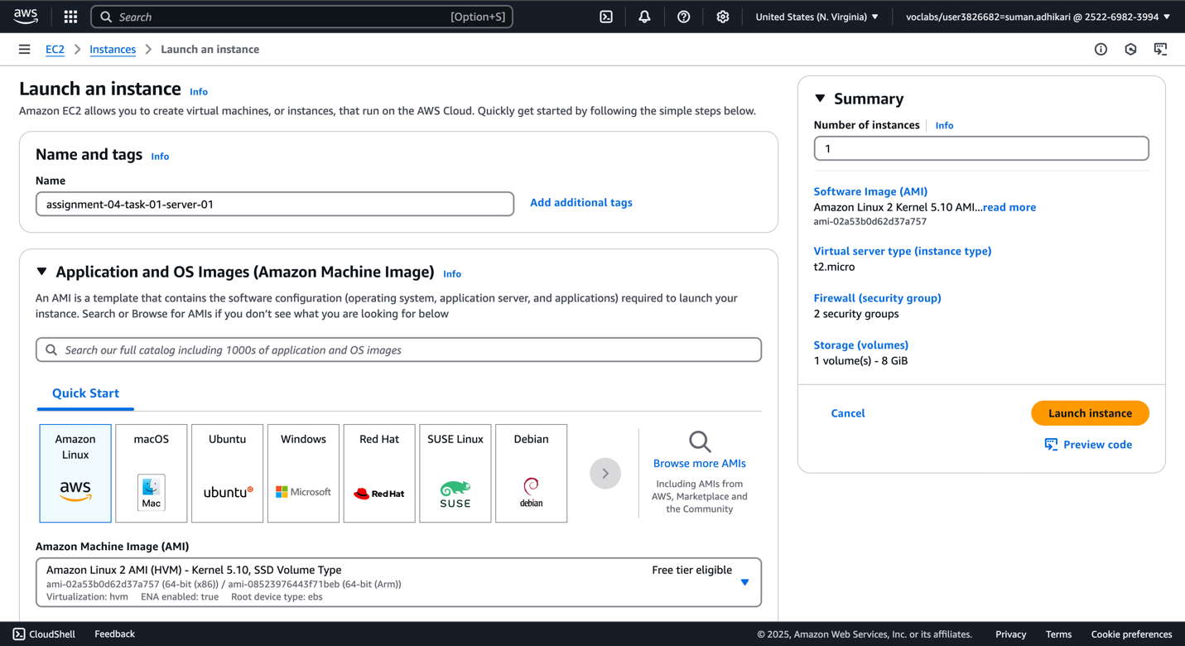

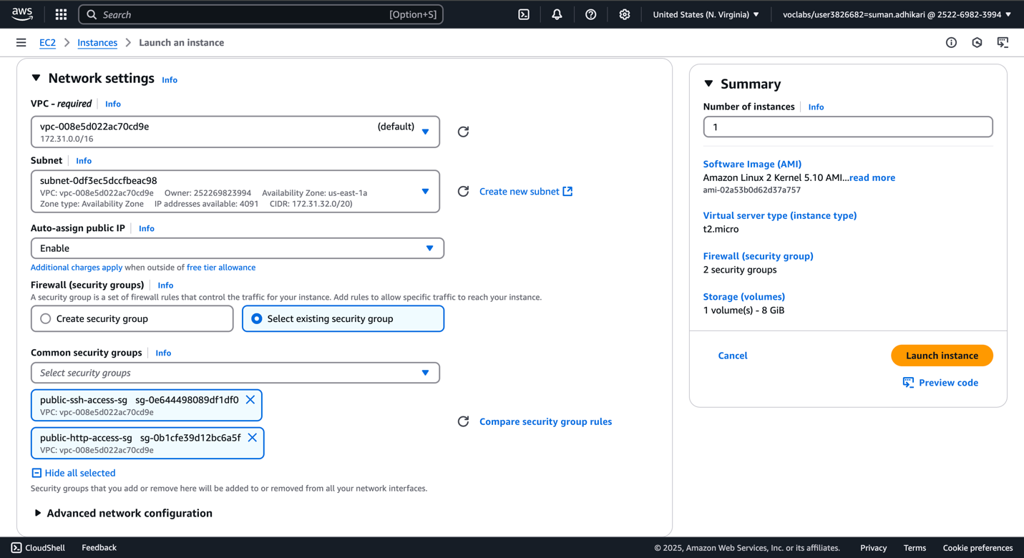

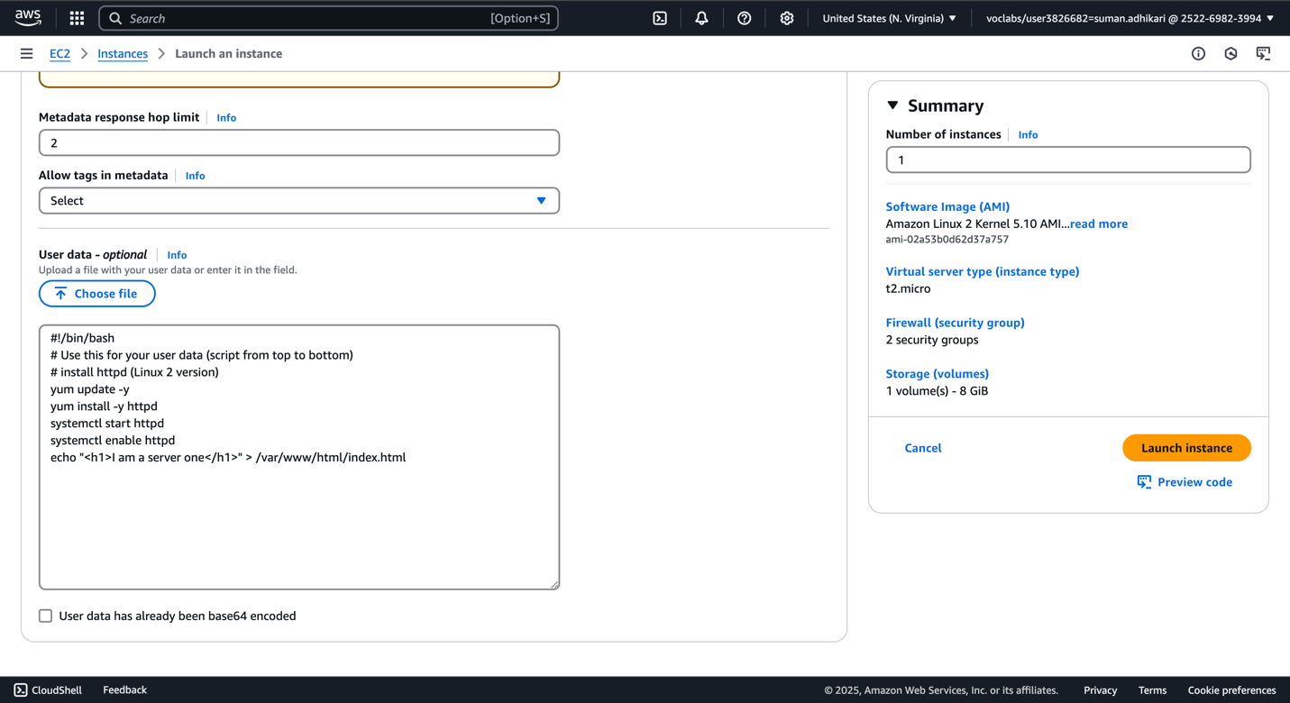

1. Launch server two.

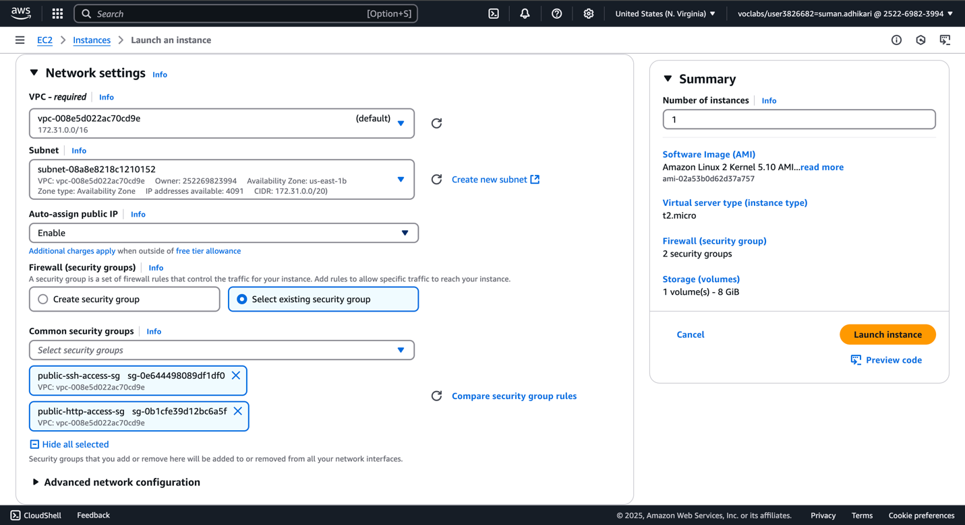

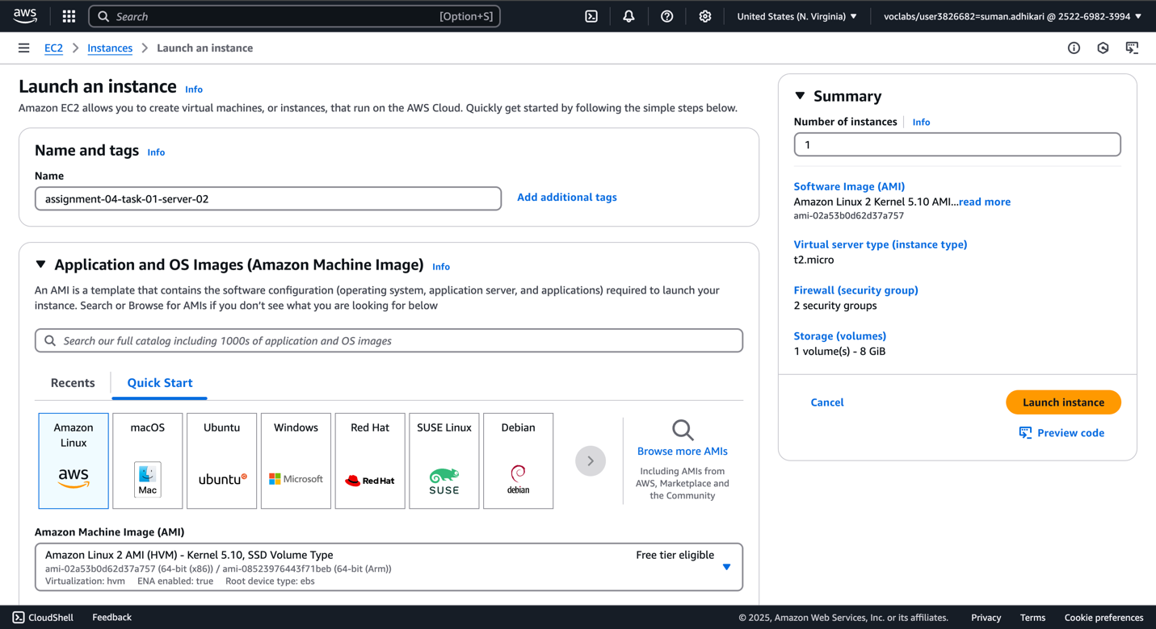

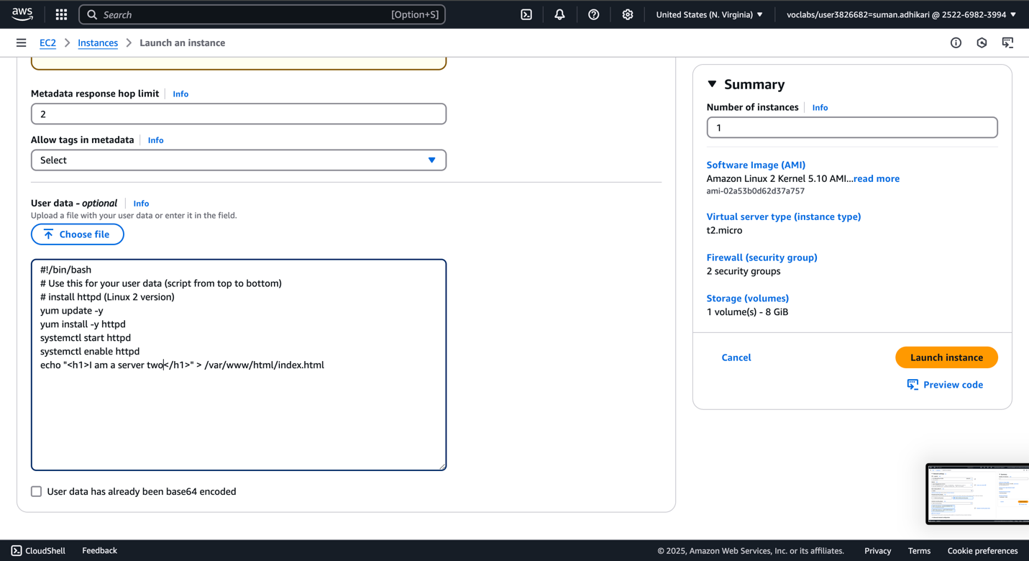

1. Check responses from two servers directly.





1. Create target group for ALB and register the two instances to the security groups. Add a health check on path / .

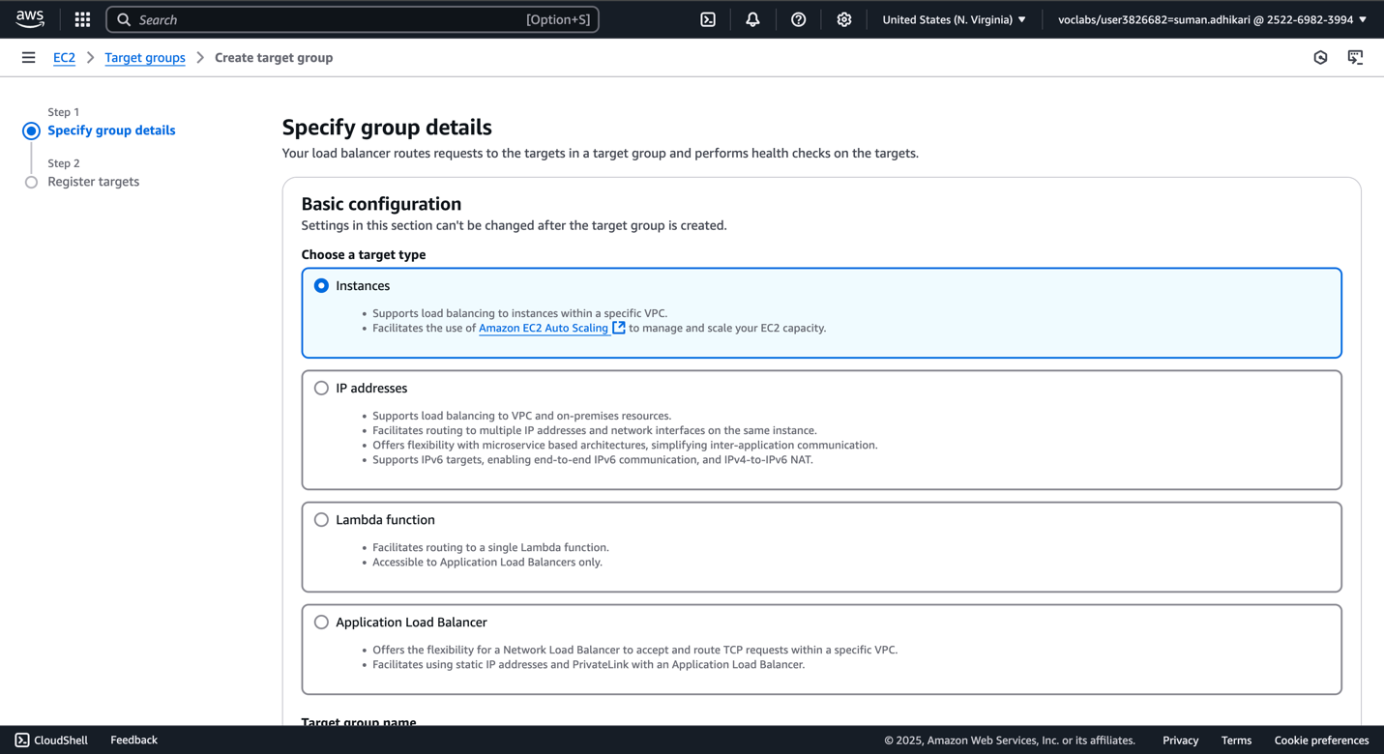

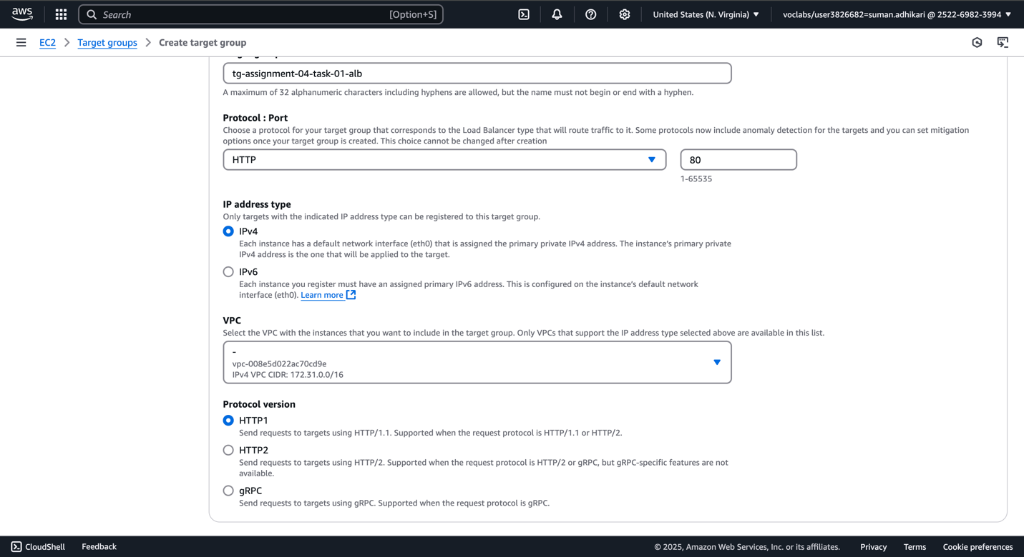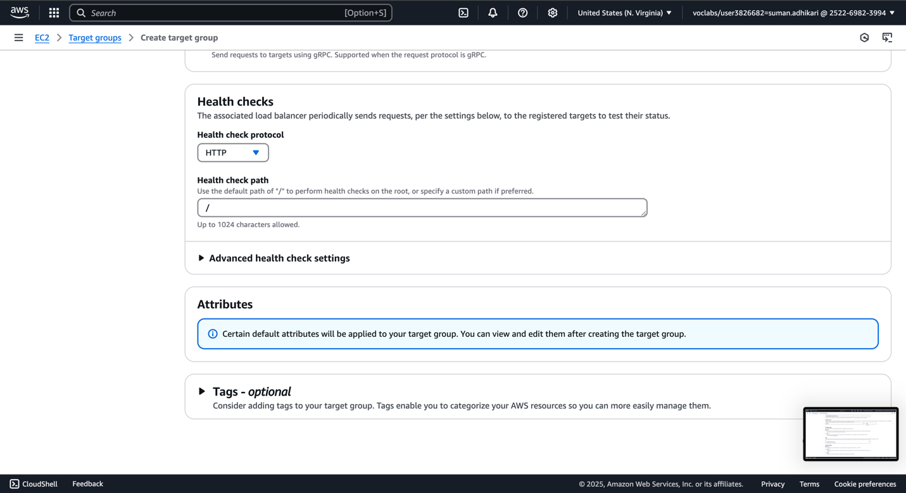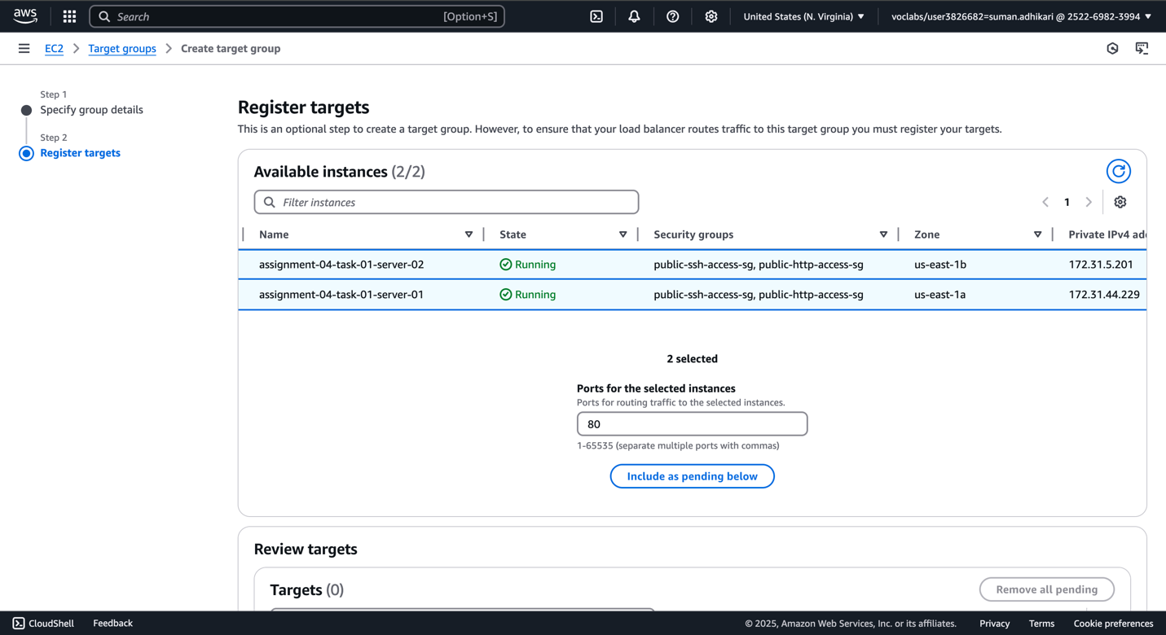

1. Target group is now created and in healthy state.

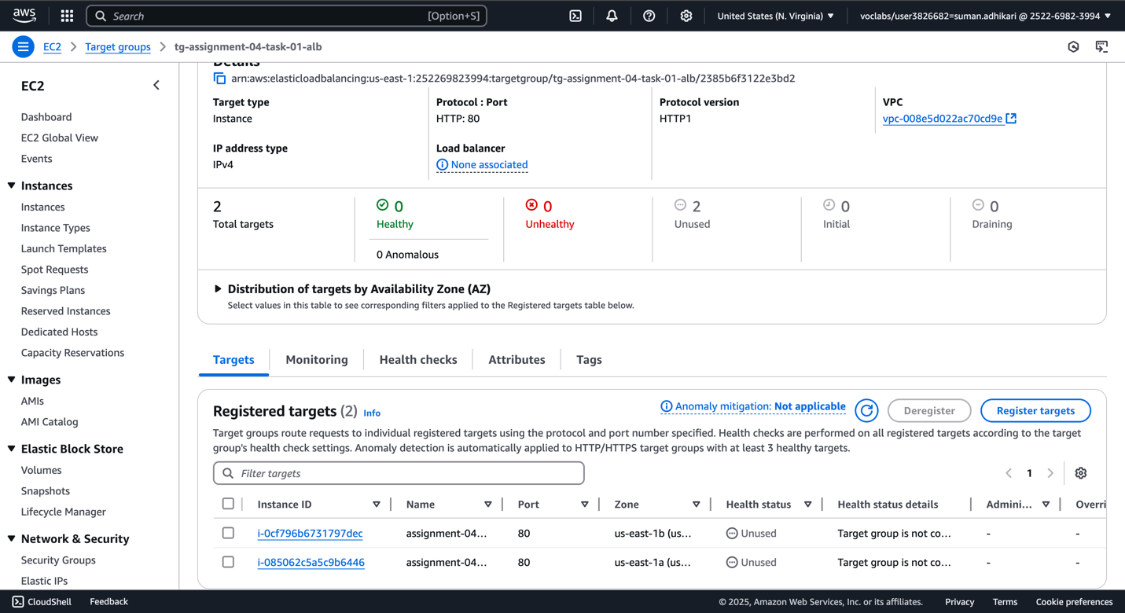

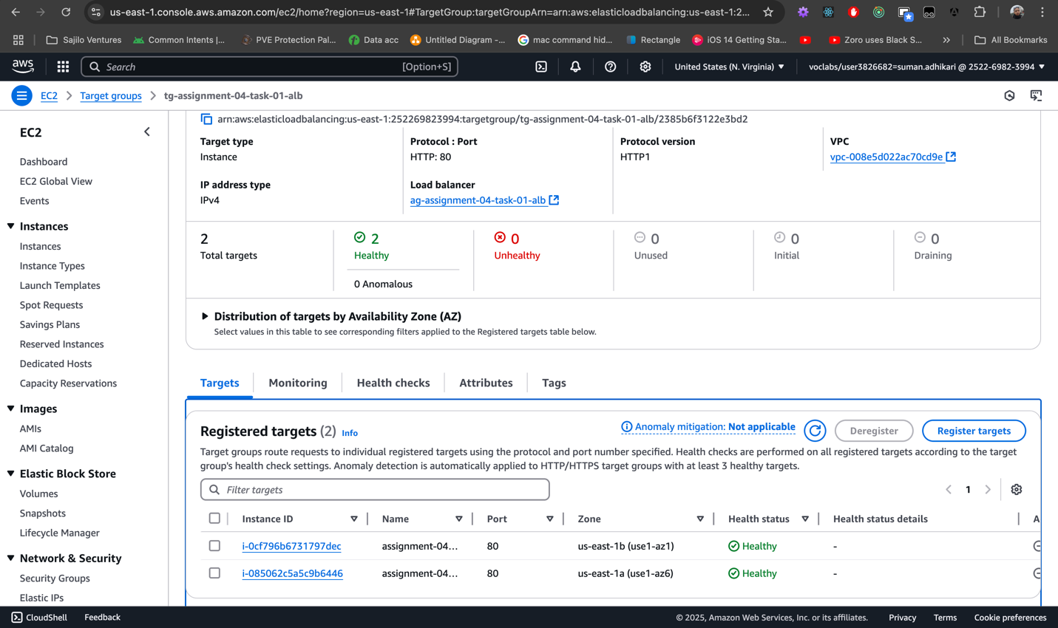

1. Create an Application Load Balancer.

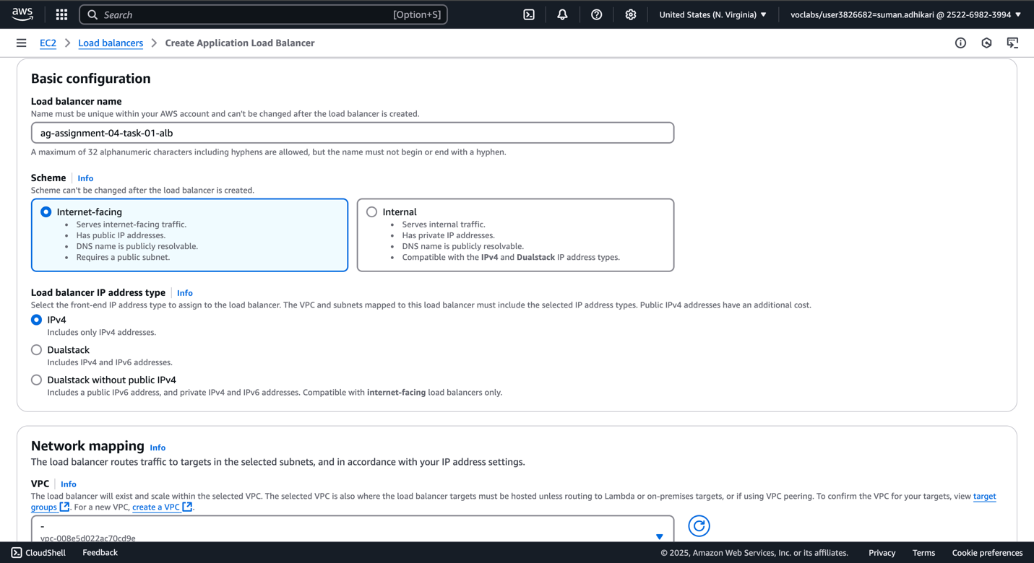

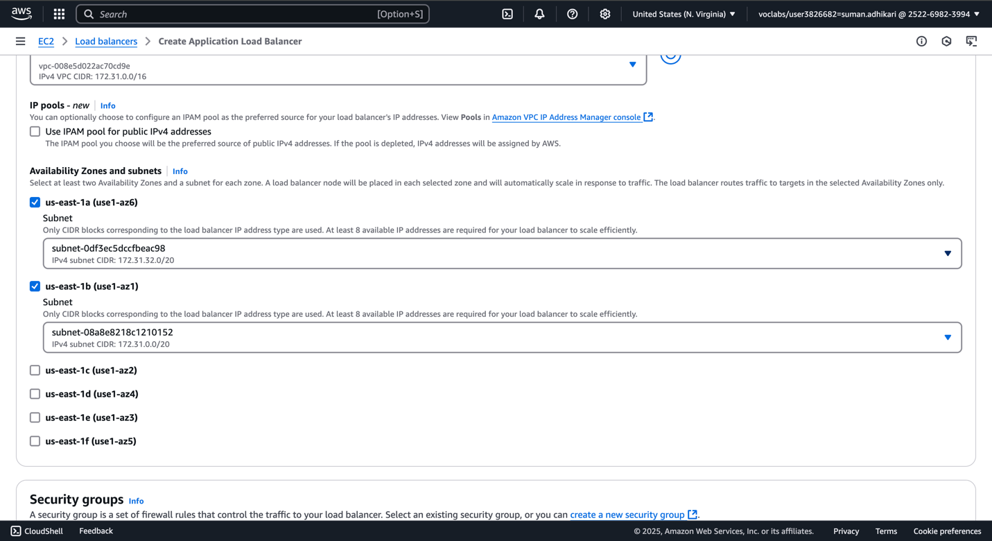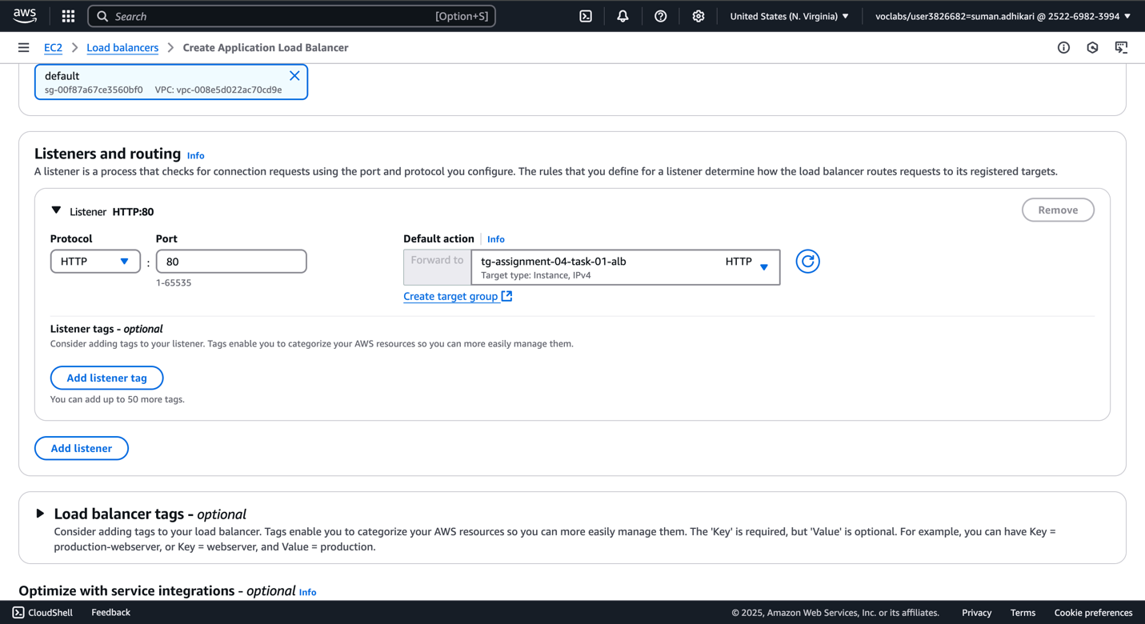

1. ALB is now created. We are receiving response from ALB endpoint as well.

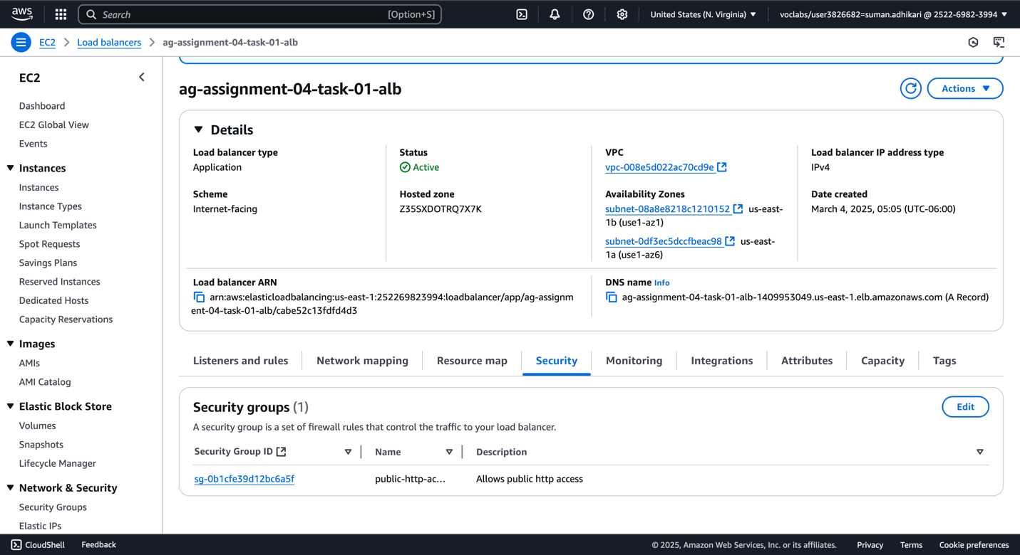



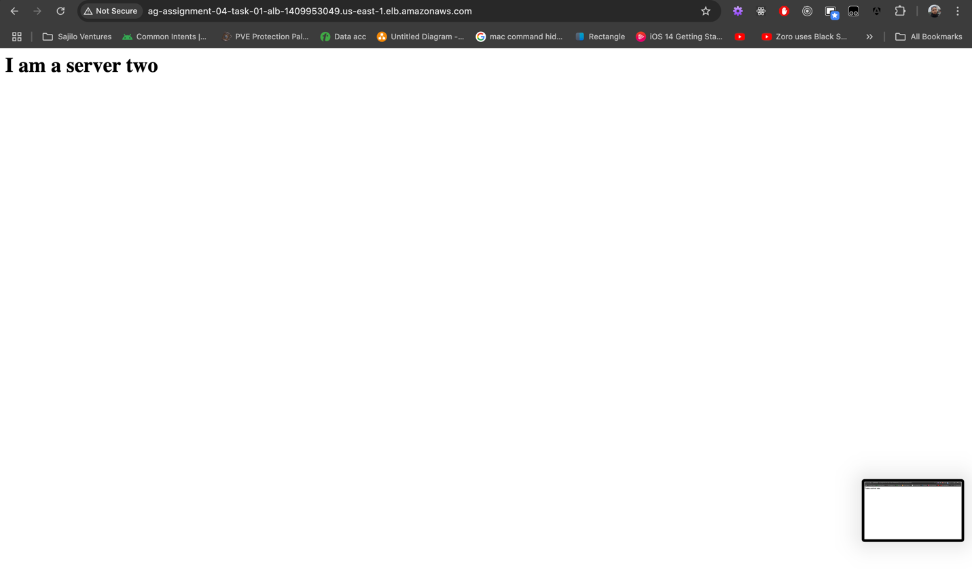

1. Now, hardening security to EC2 instances so that only ALB has access to it. Below we see updates to ALB security group and EC2 instances security group. ALB has ‘assignment-04-task-01-alb-sg’ group and EC2 instances have ‘private-assignment-04-task-01-alb-only-access’ group.

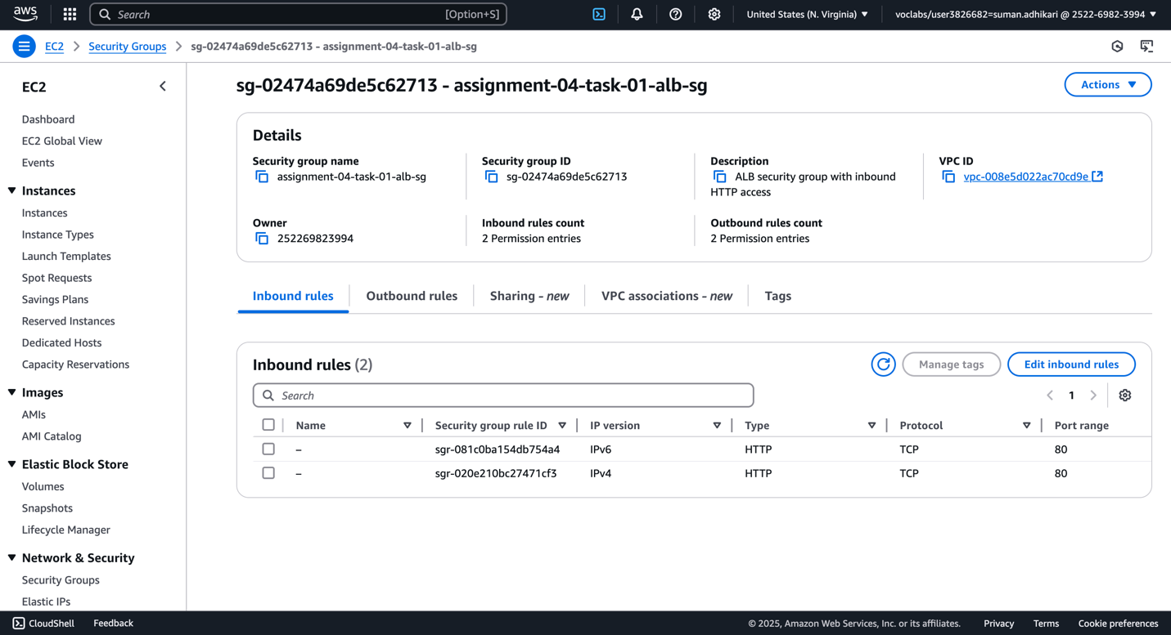

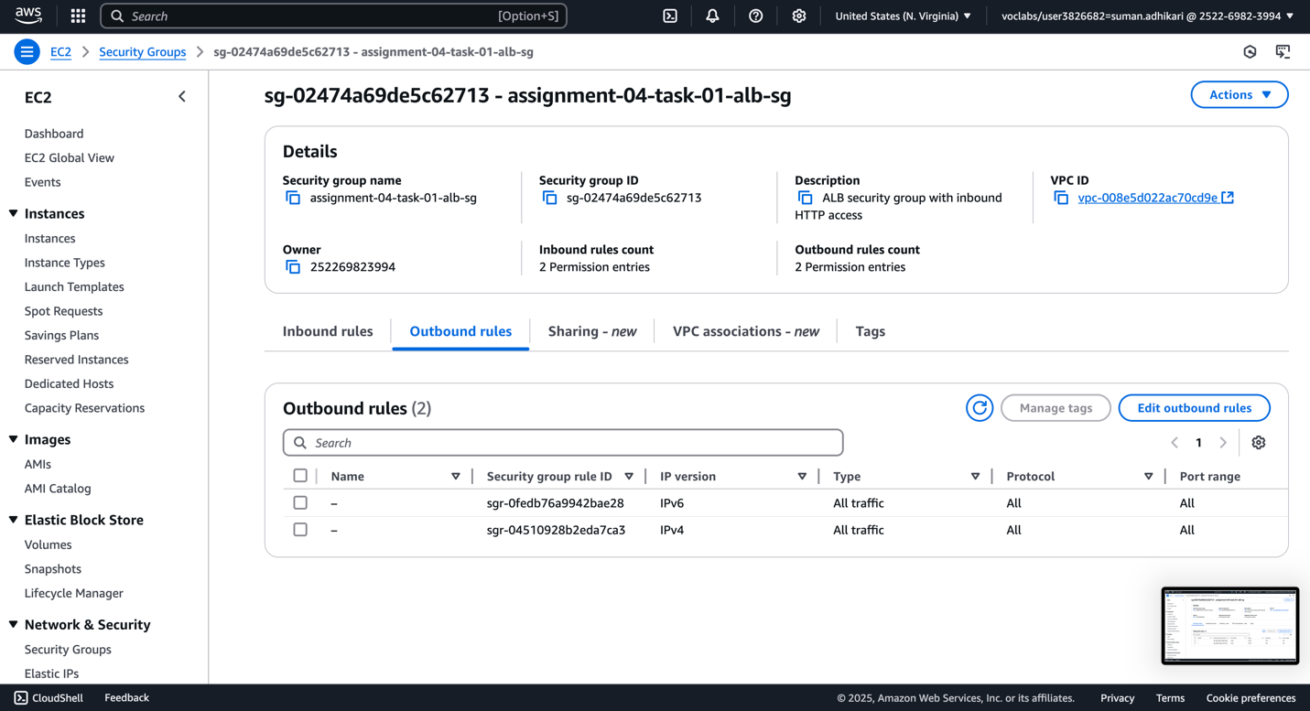

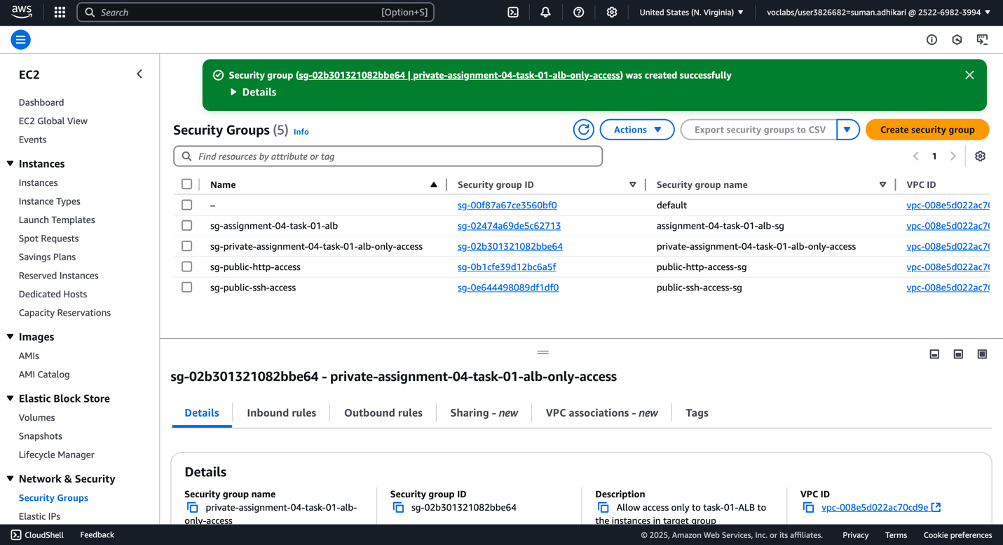

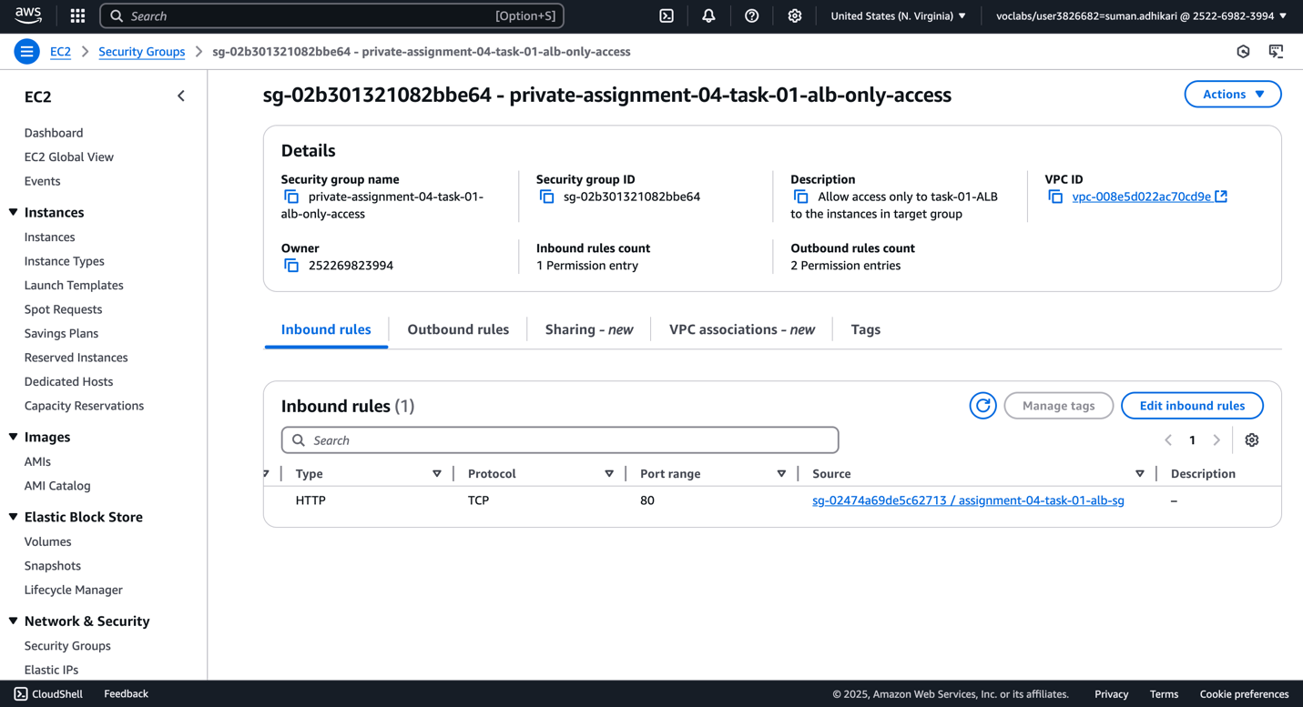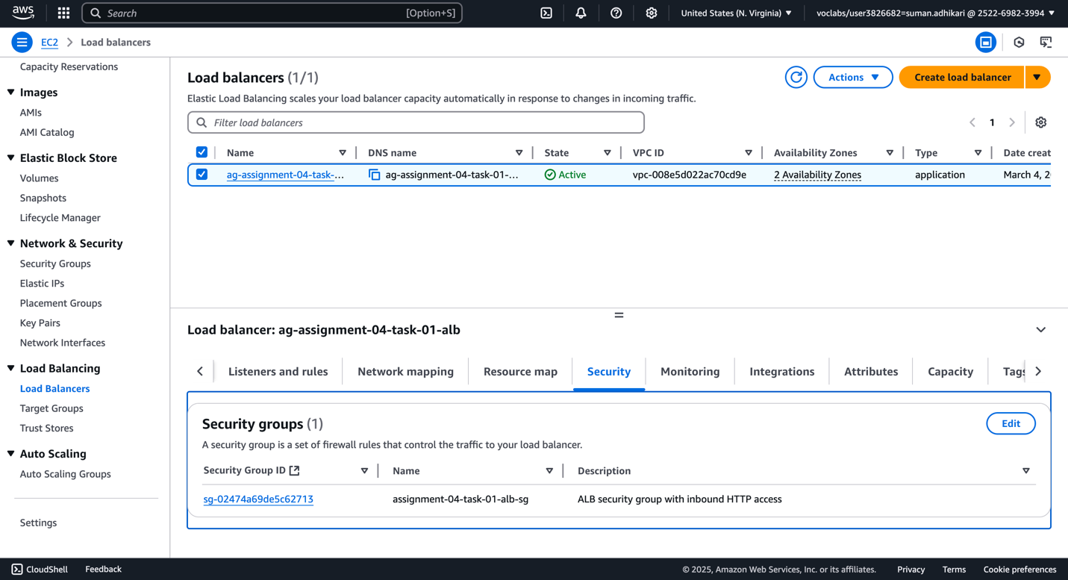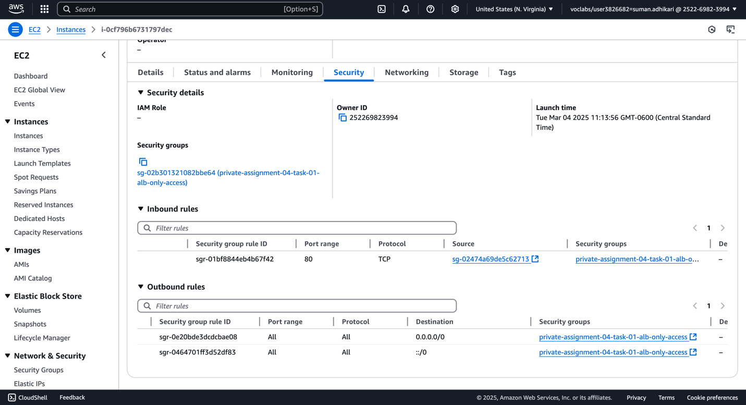

1. Check response from ALB now. We are receiving response only from ALB now.

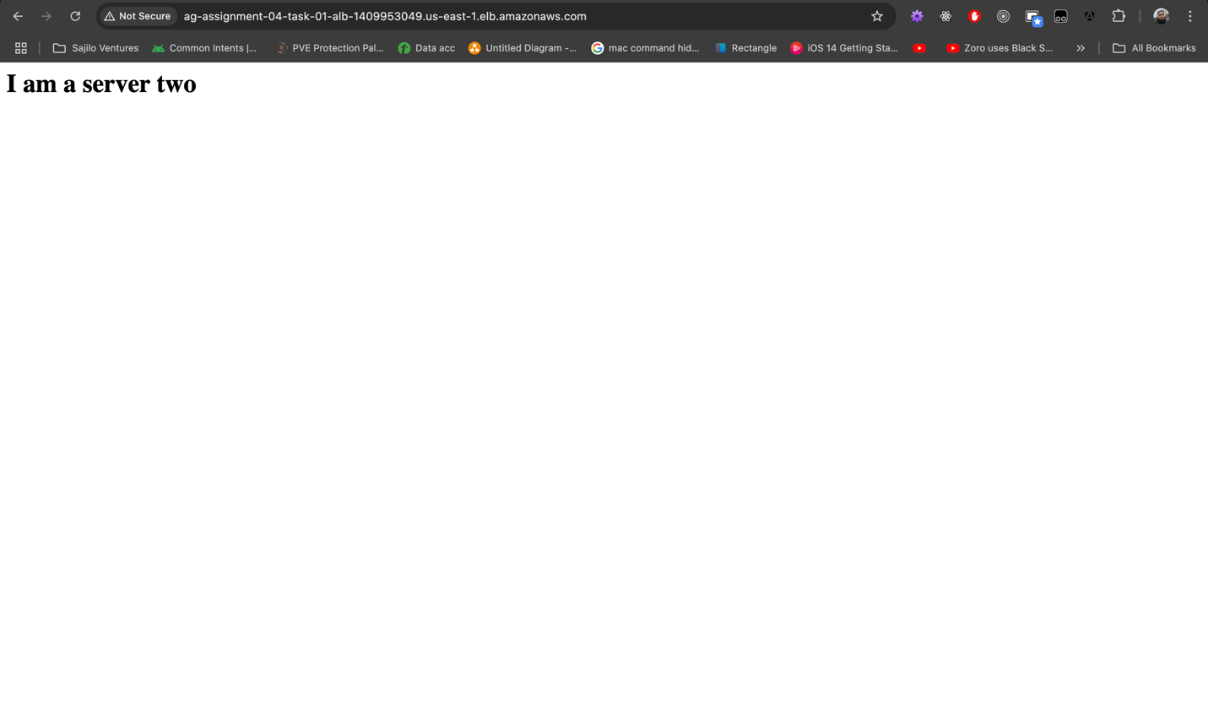

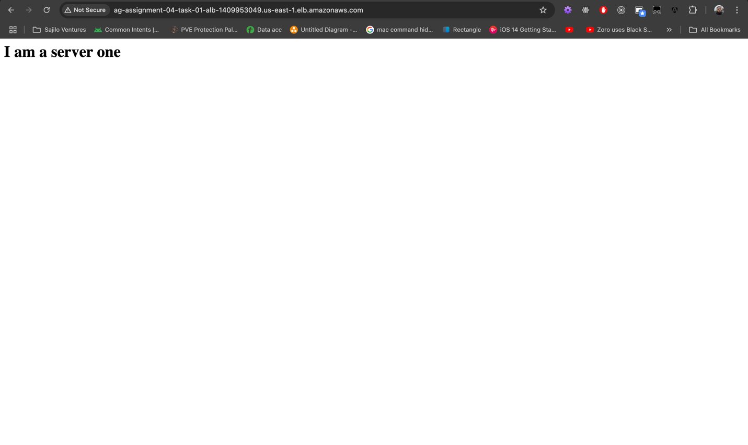

## Task #2 – Run web servers behind NLB

We will be re-using the instances from Task #1. In summary, we will only create a new security group for EC2 instances to receive traffic from NLB and a security group for the NLB along with a new target group with TCP protocol for NLB to utilize. Everything else will work as Task #1 instances are already preconfigured with HTTP servers.

1. Create security group for NLB.

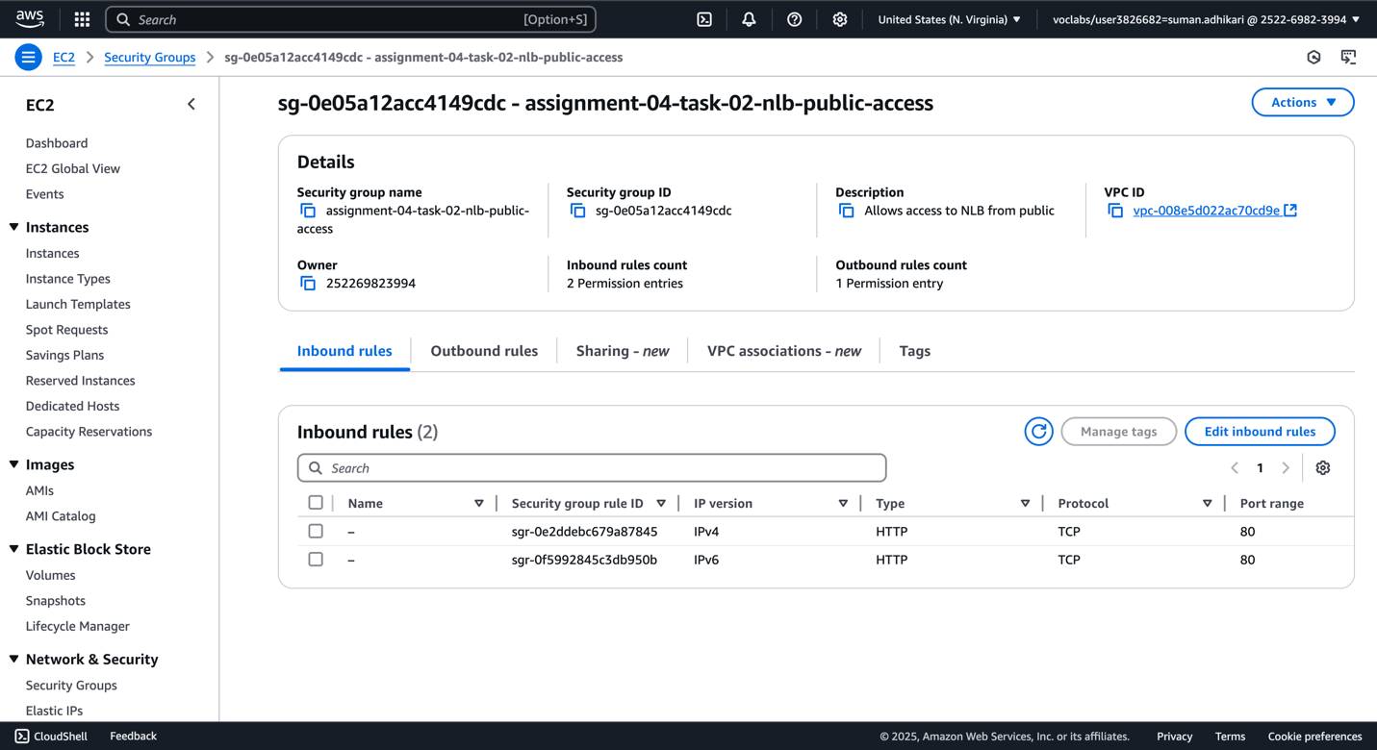

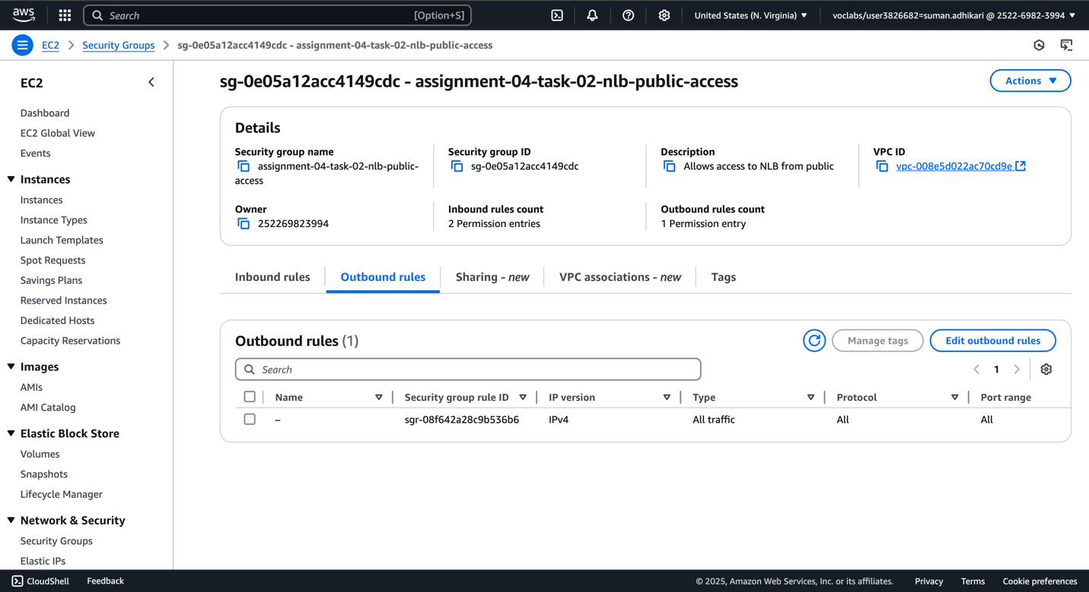

1. Create security group for EC2 instances to allow connection from NLB using TCP.

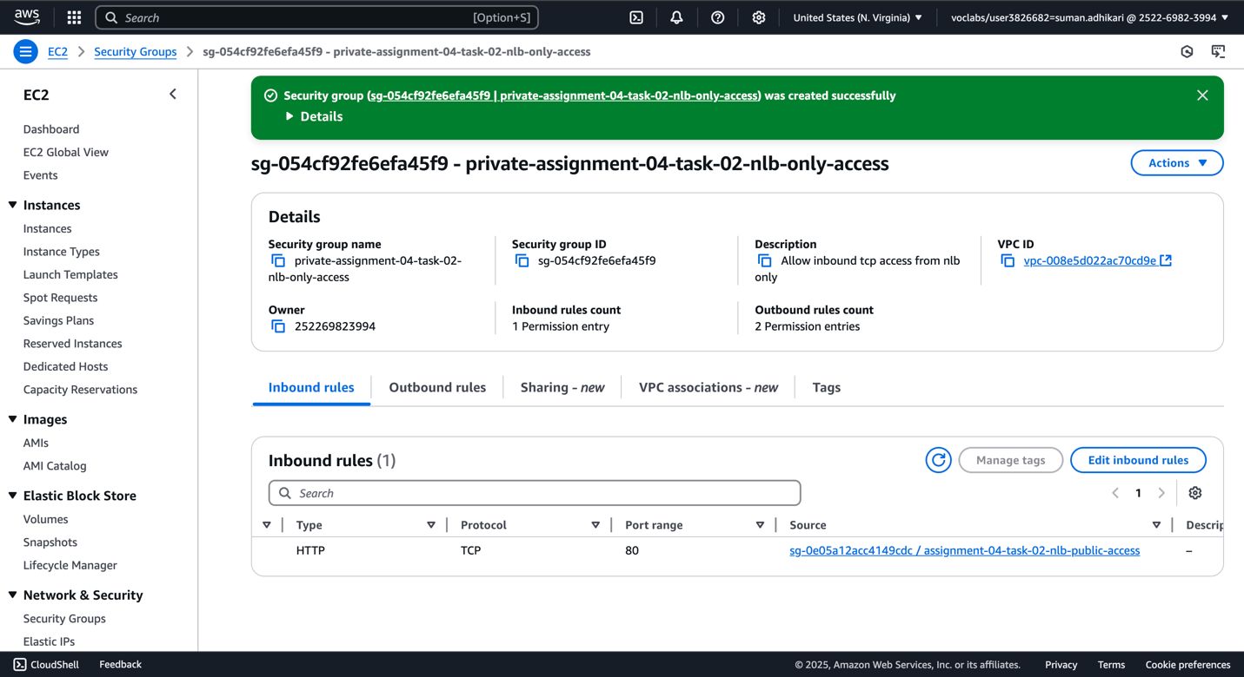

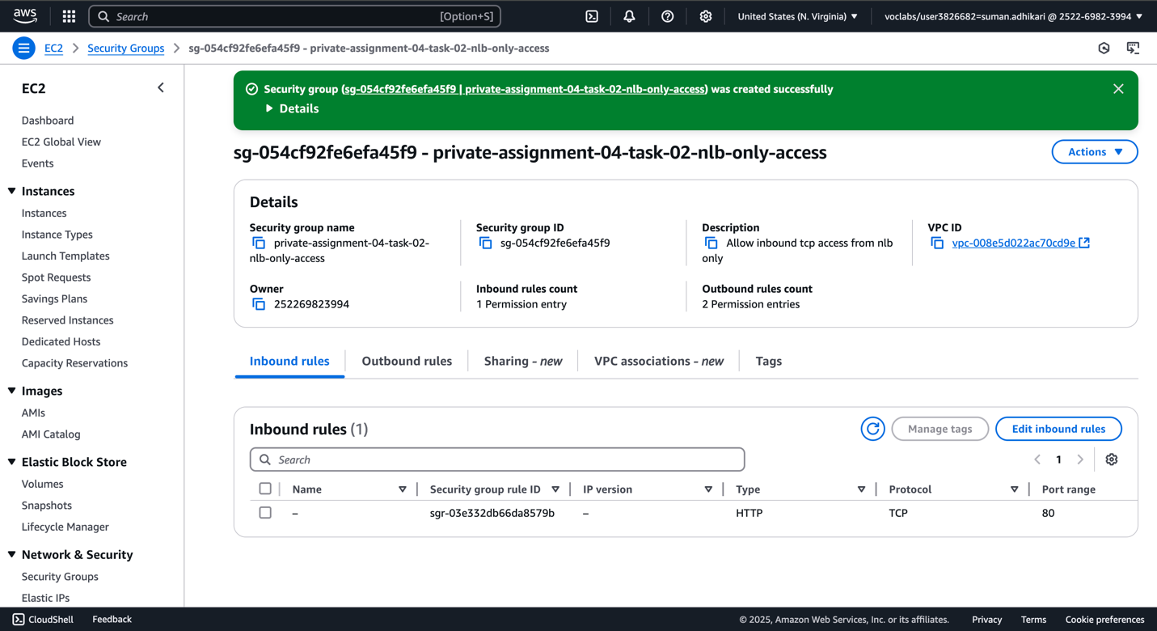

1. Attach ‘private-assignment-04-task-02-nlb-only-access’ security group to instances.

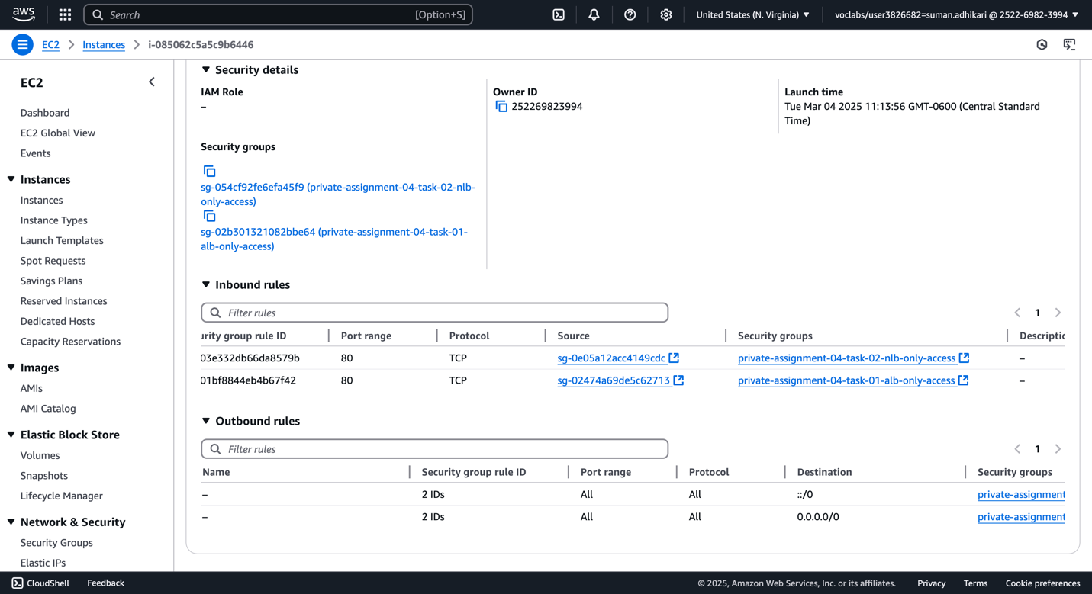

1. Create a target group for NLB and register instances with it.

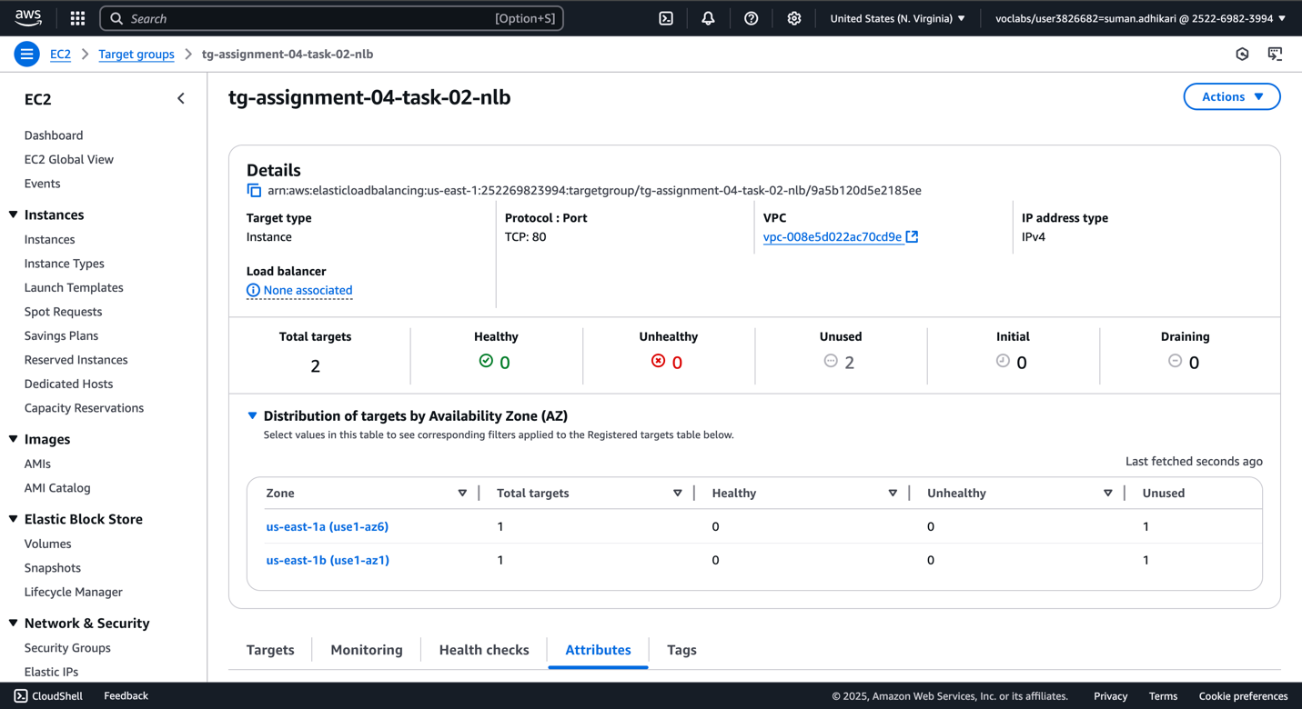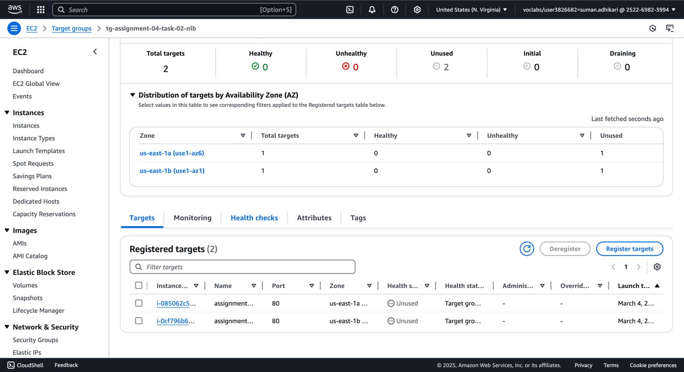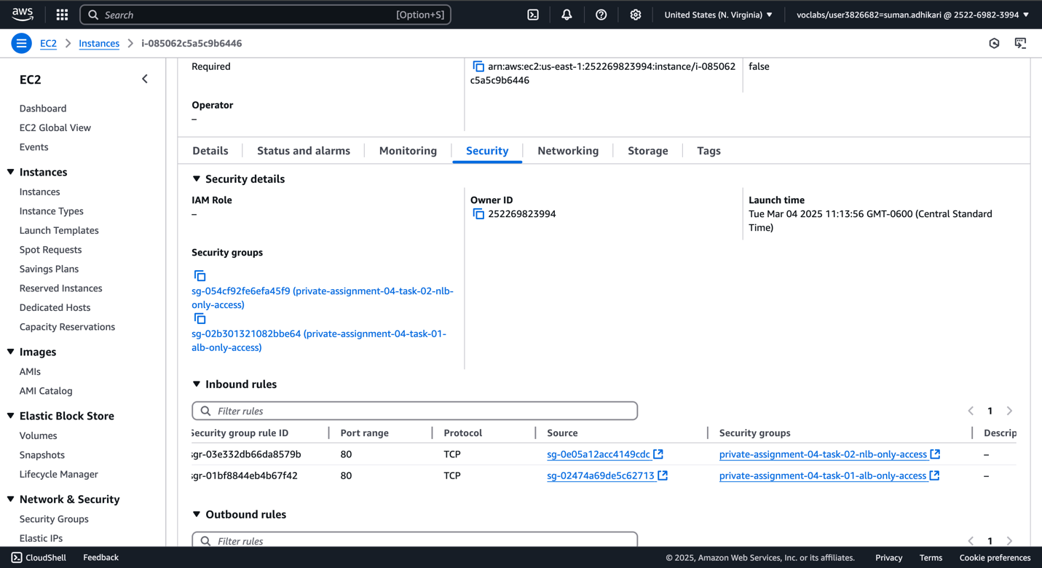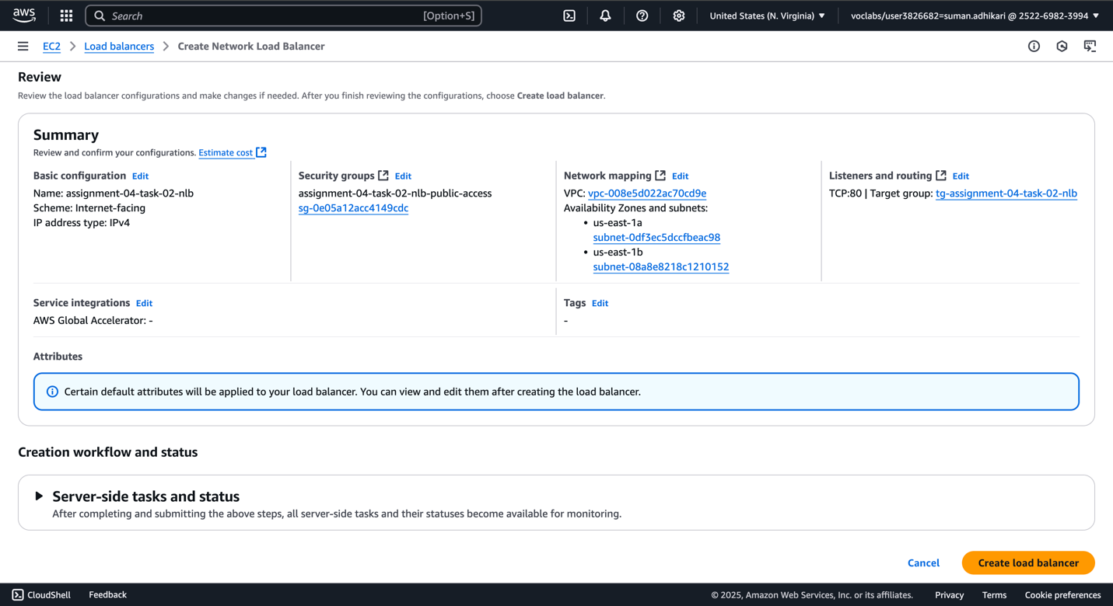

1. Instances are now healthy. And we are getting response from NLB.

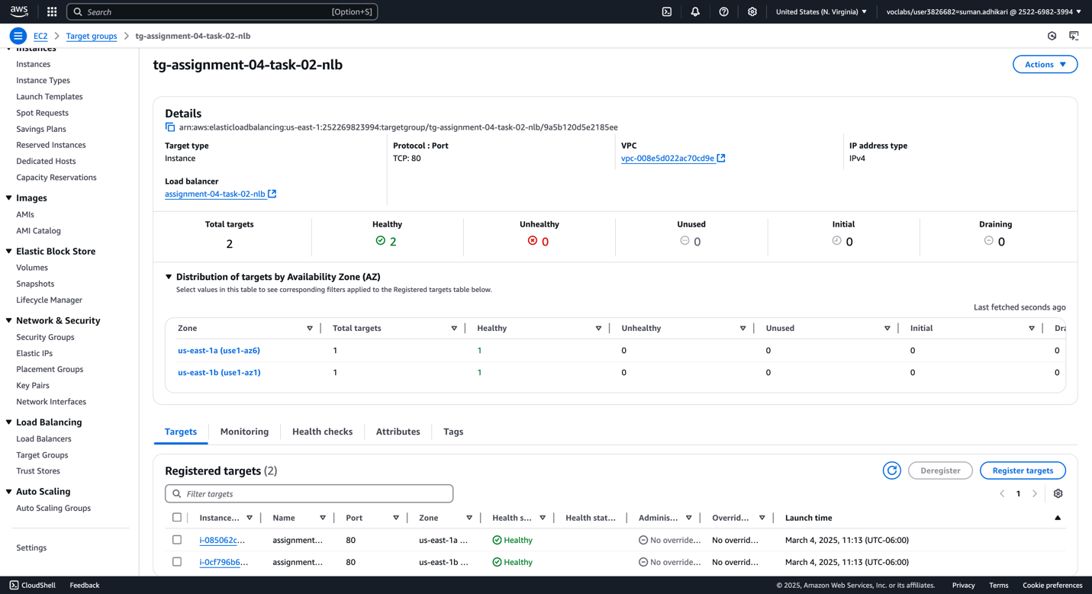

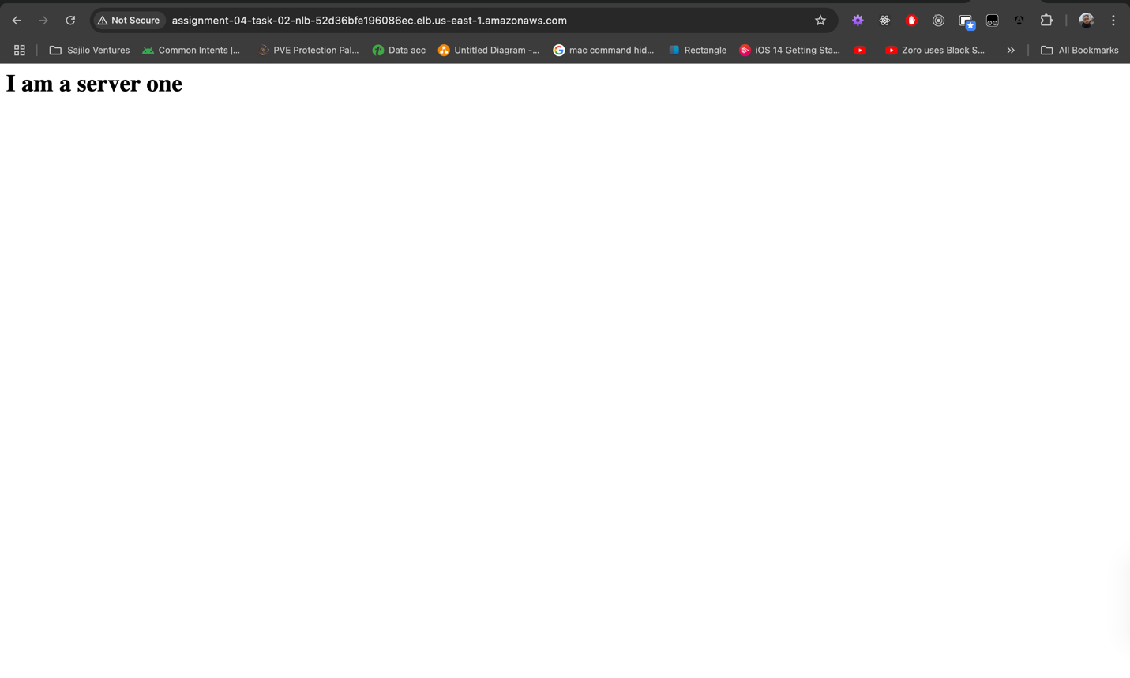

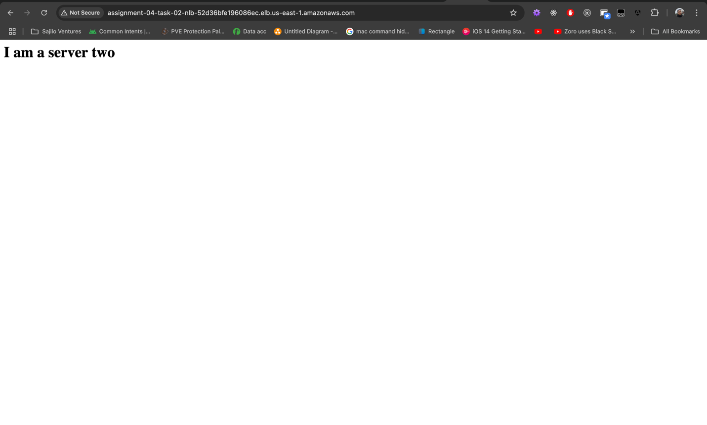

## Task #3 – Run the web server in ASG

Here, we will first need a launch template for the ASG to run on. Then we will need to create the ASG itself and assign the launch template to it. While assigning the launch template, for creating ASG, we will need to select the VPC and availability zones and the target group we will use for the ASG to manage. Along with that we need to specify the desired, min and max instances to have and a target metric for Cloud Watch to check for to trigger the auto scaling. We will use 60% CPU utilization for that and will be using the stress tool to simulate the CPU load.

Note: we will be reusing the ALB and target group from task #1 for cost and time effectiveness.

1. Create a launch template.

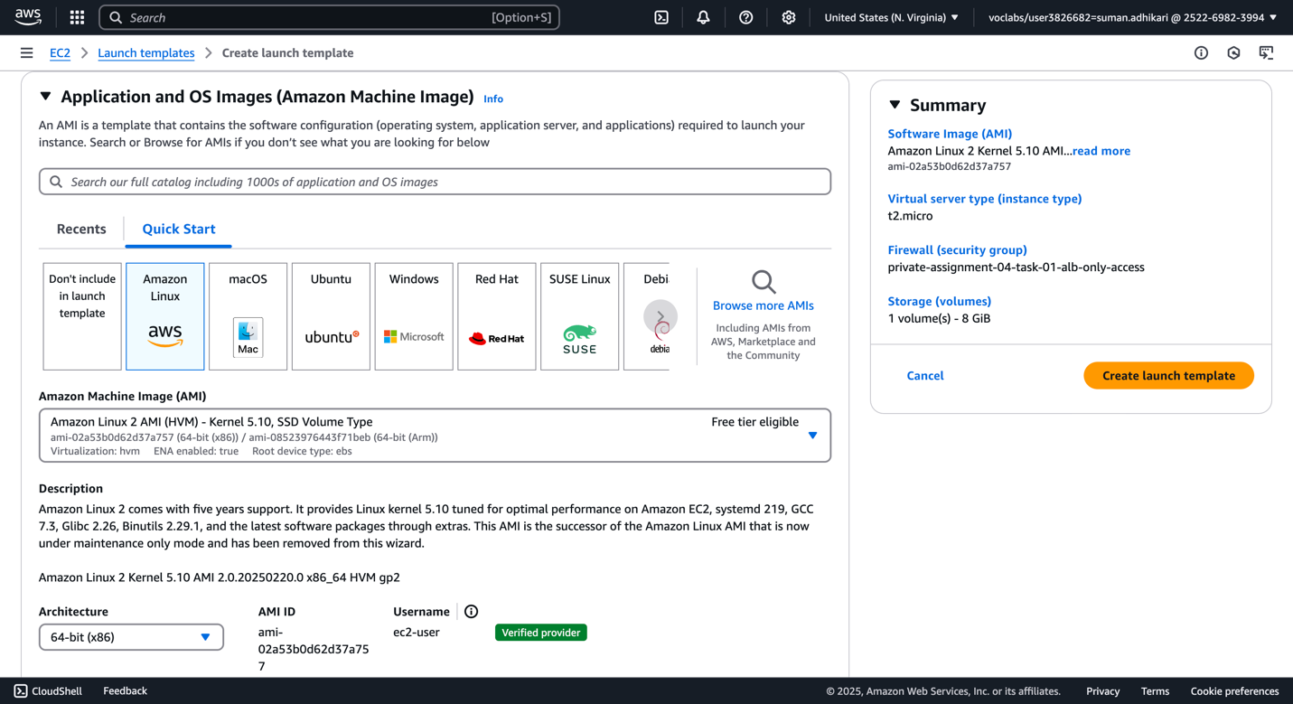

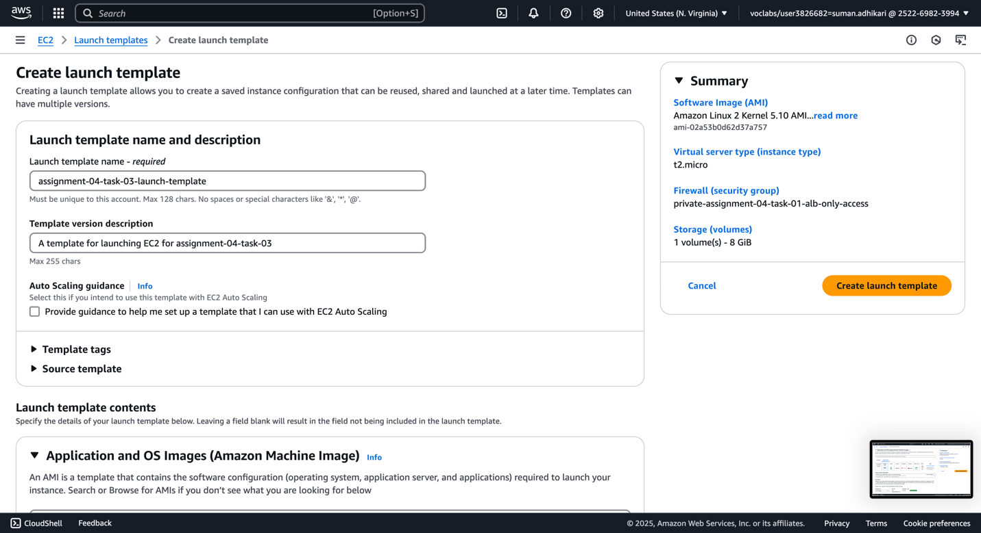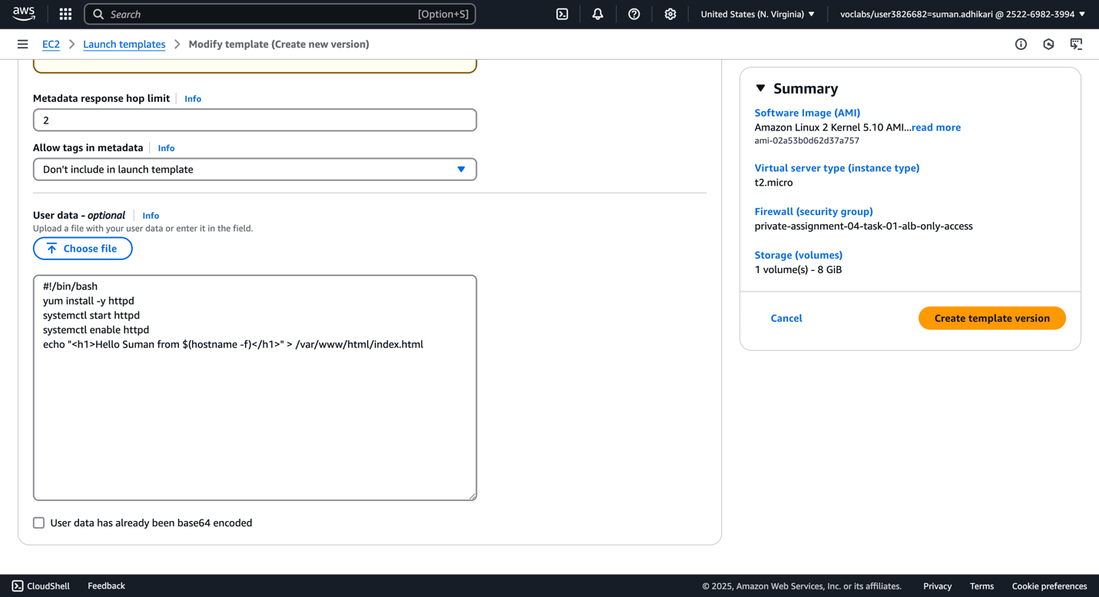

1. Create the Auto Scaling group (ASG) with above launch template.

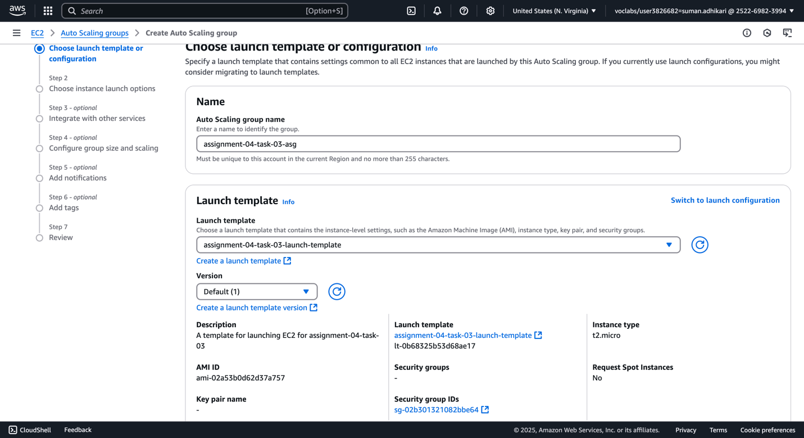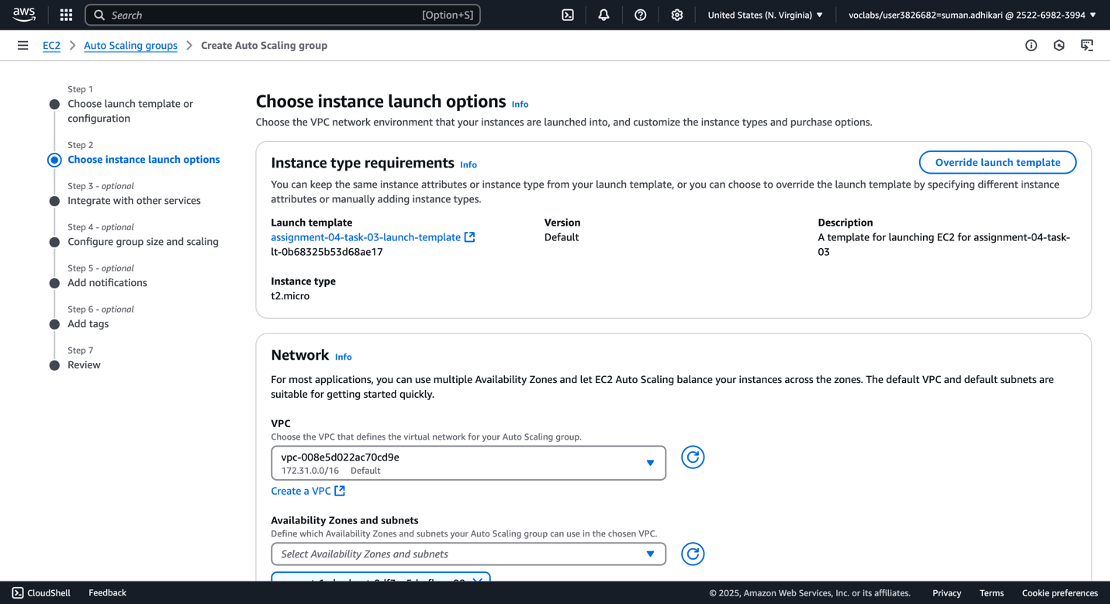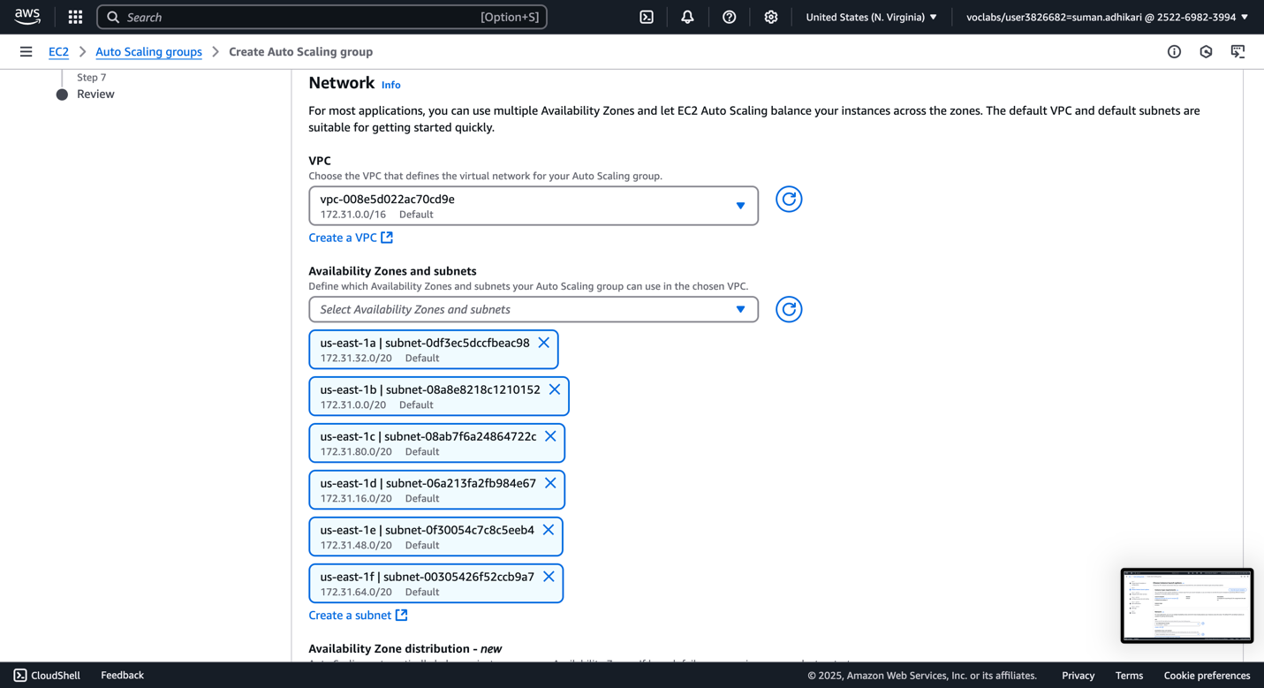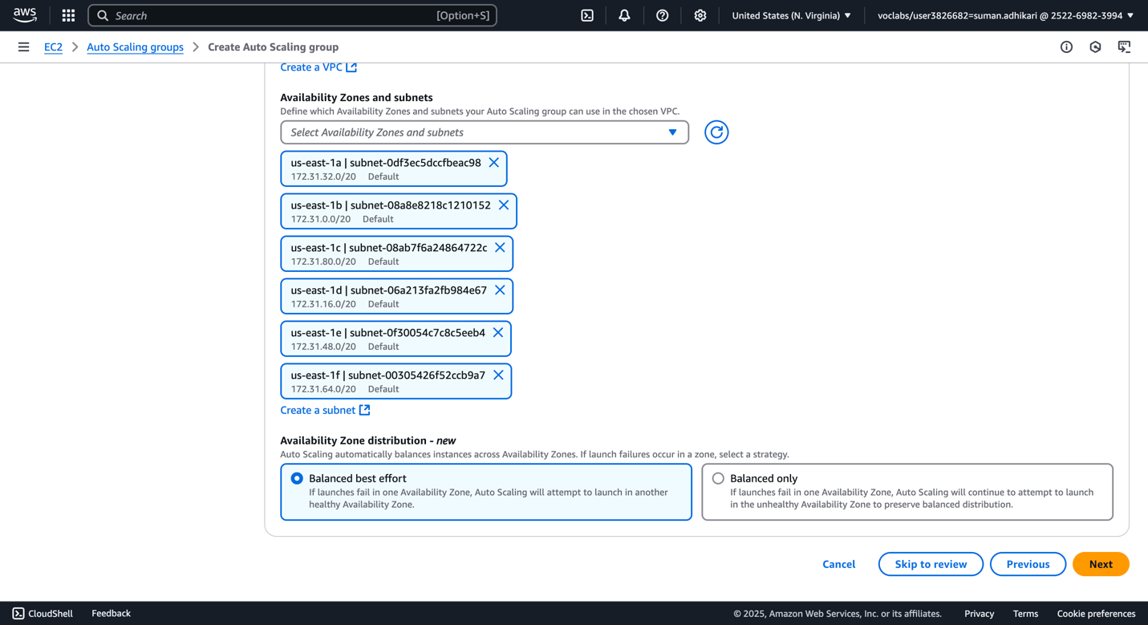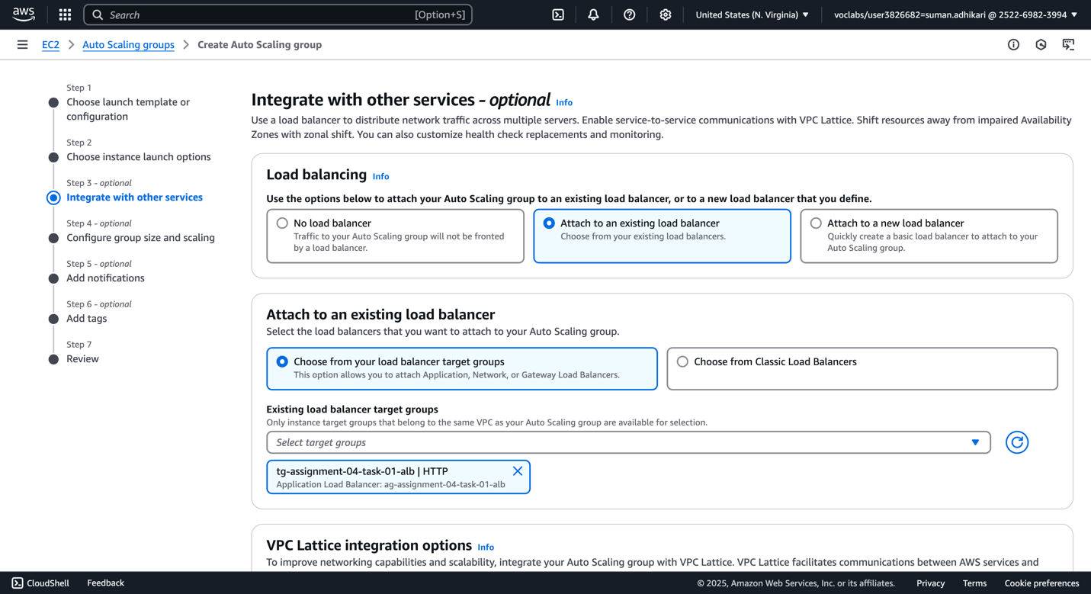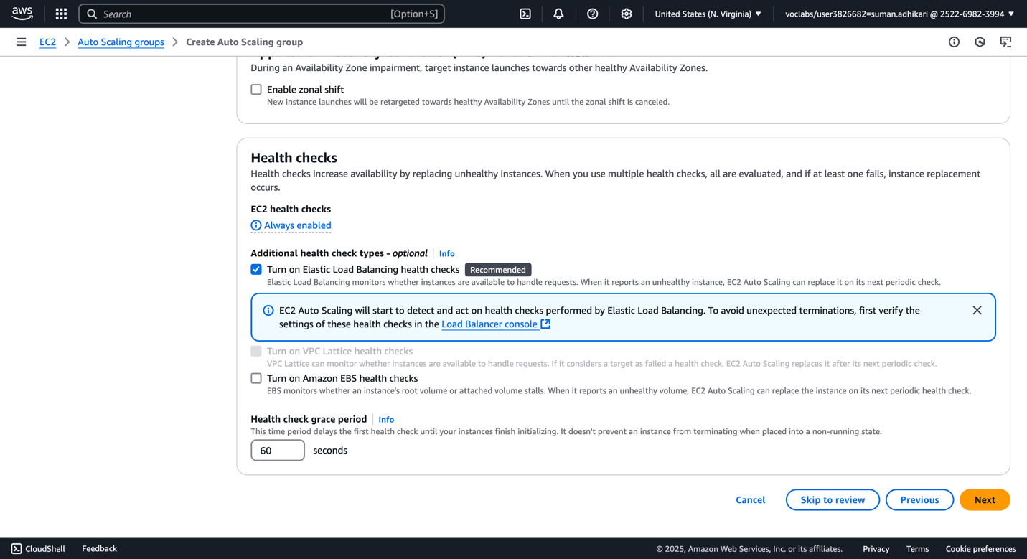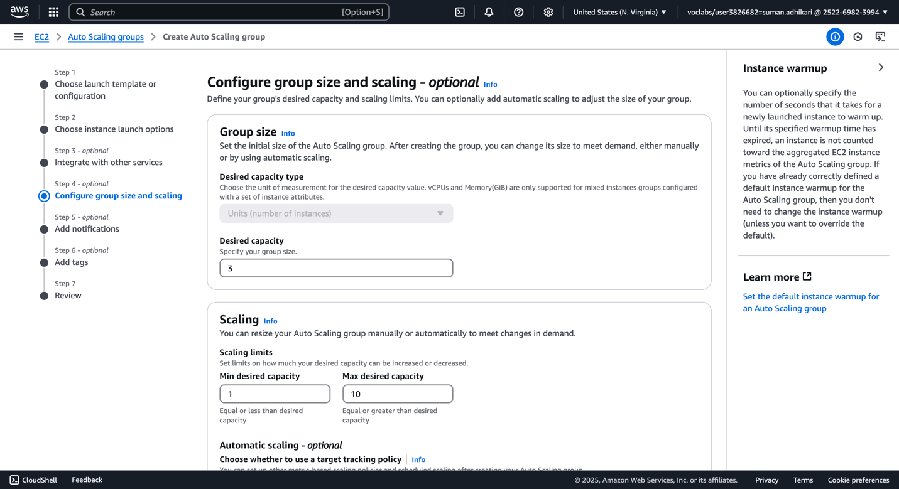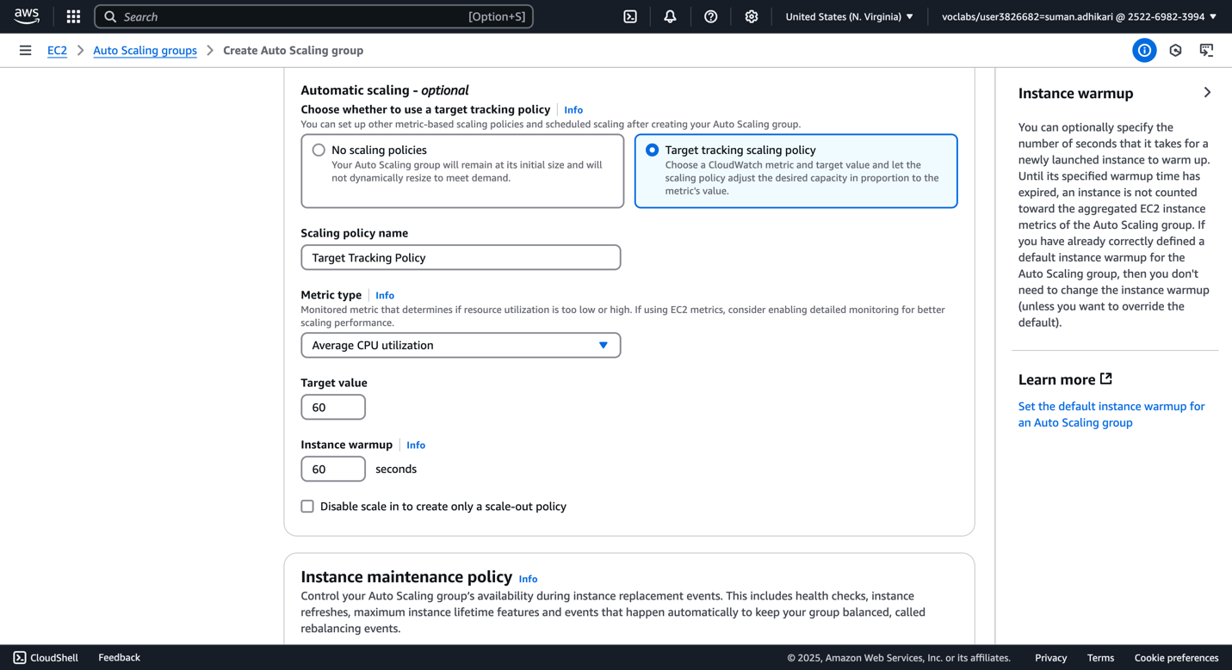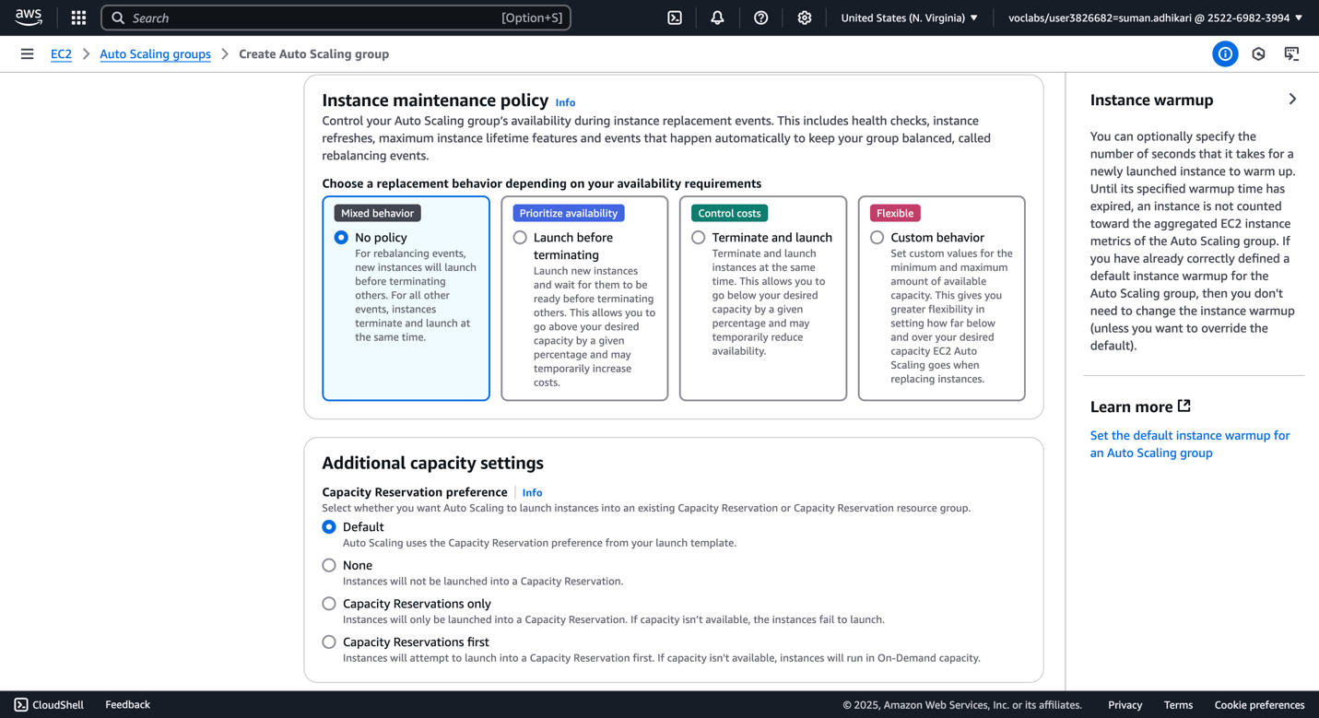

1. Review the ASG settings.

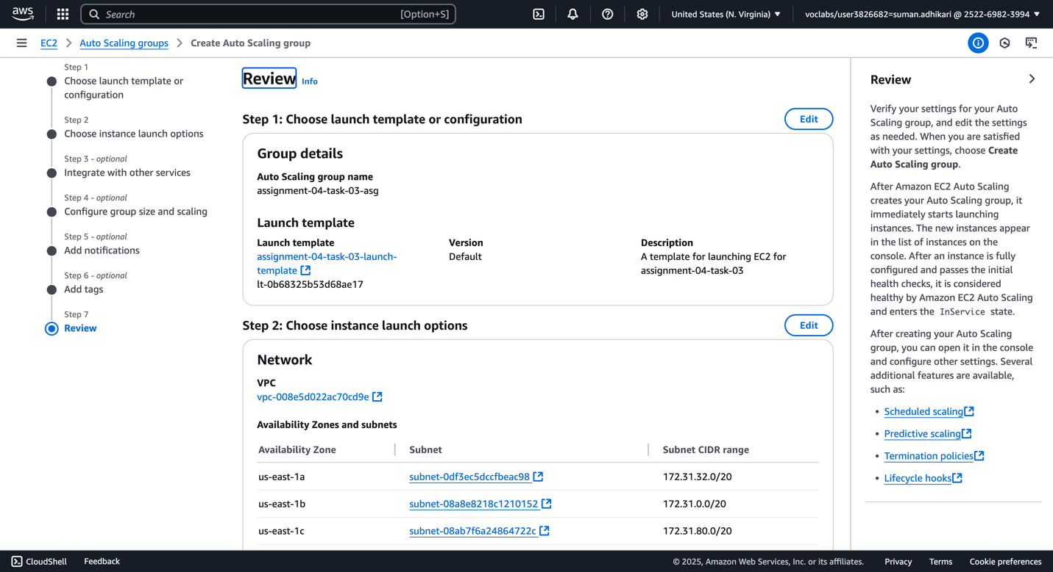

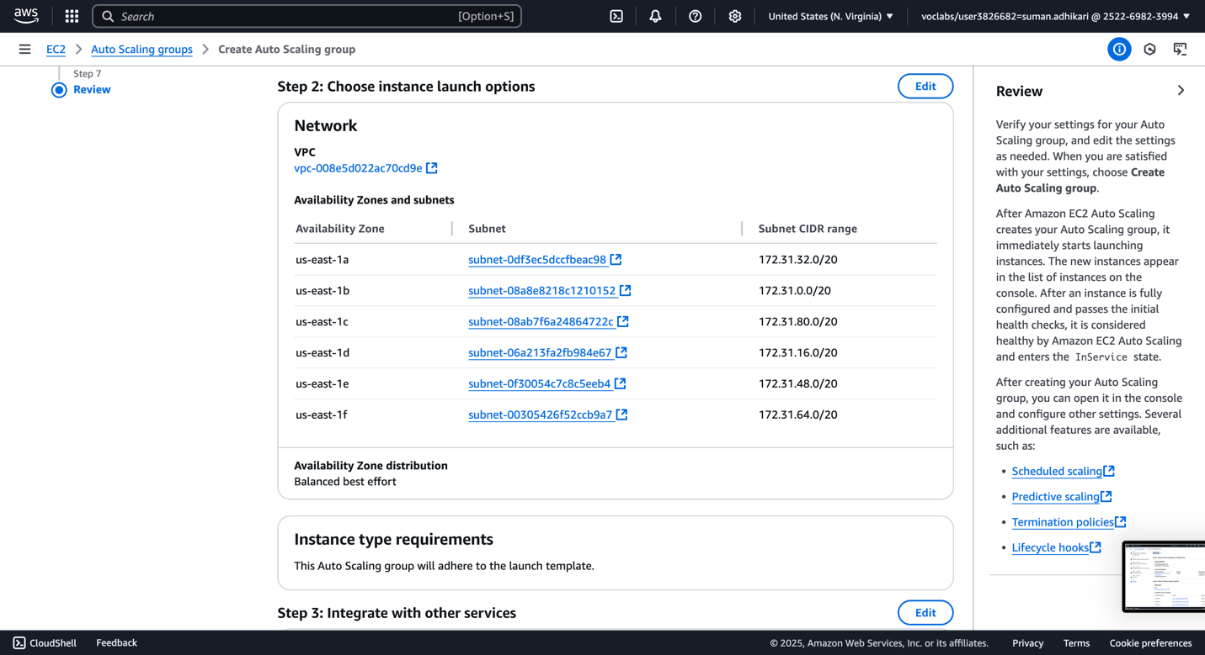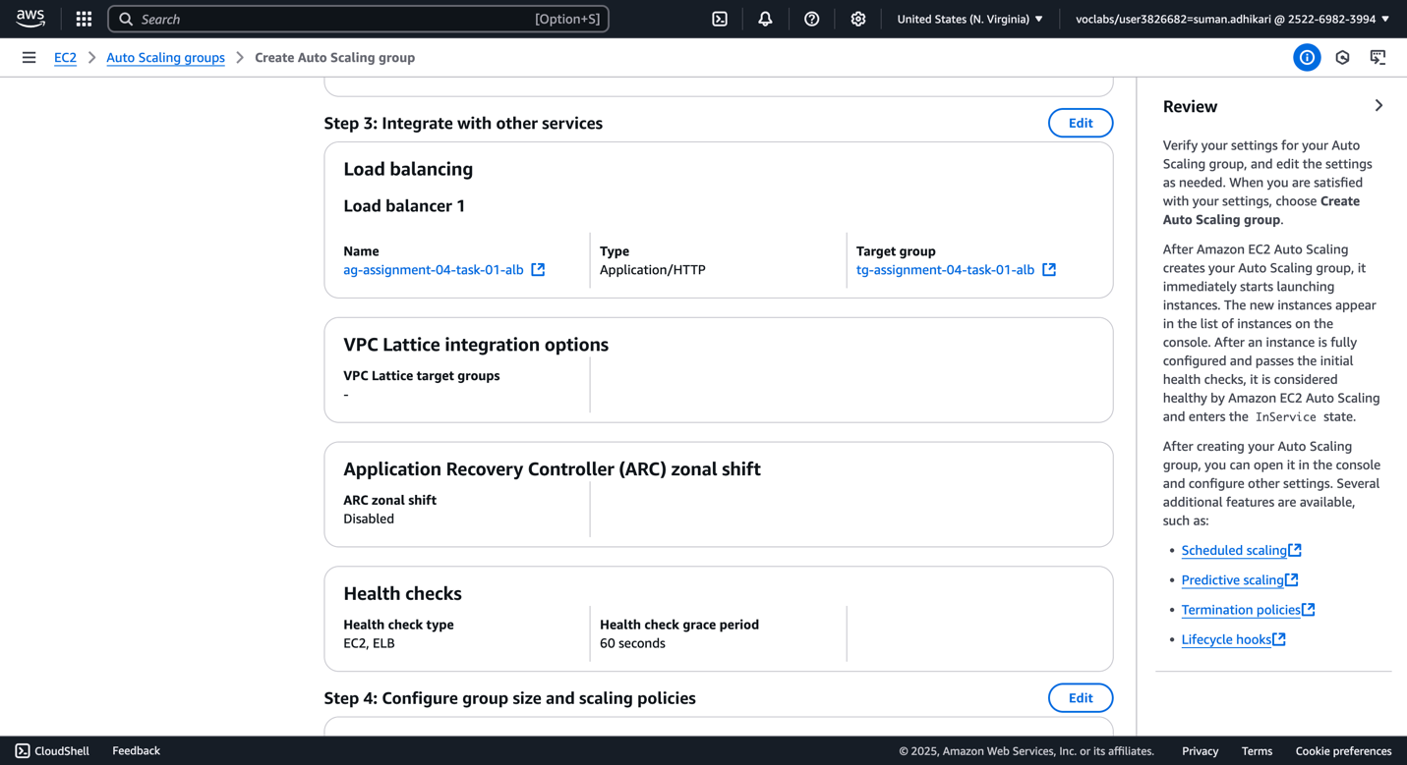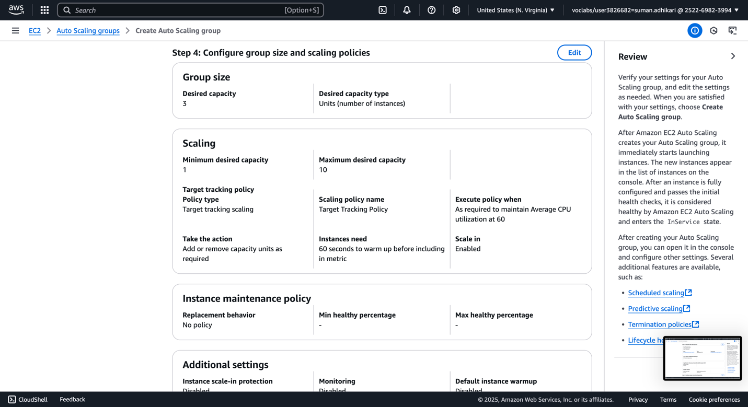

1. ASG is now active and here is the initial activity.

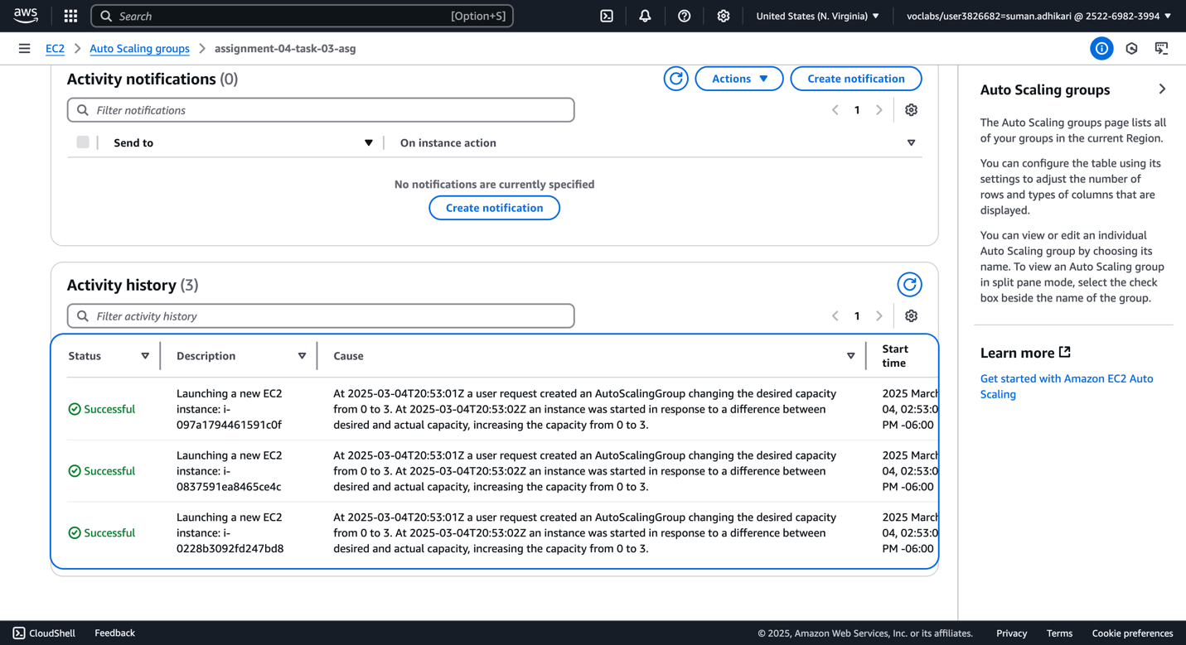

1. Add SSH access to instance for the stress test now.

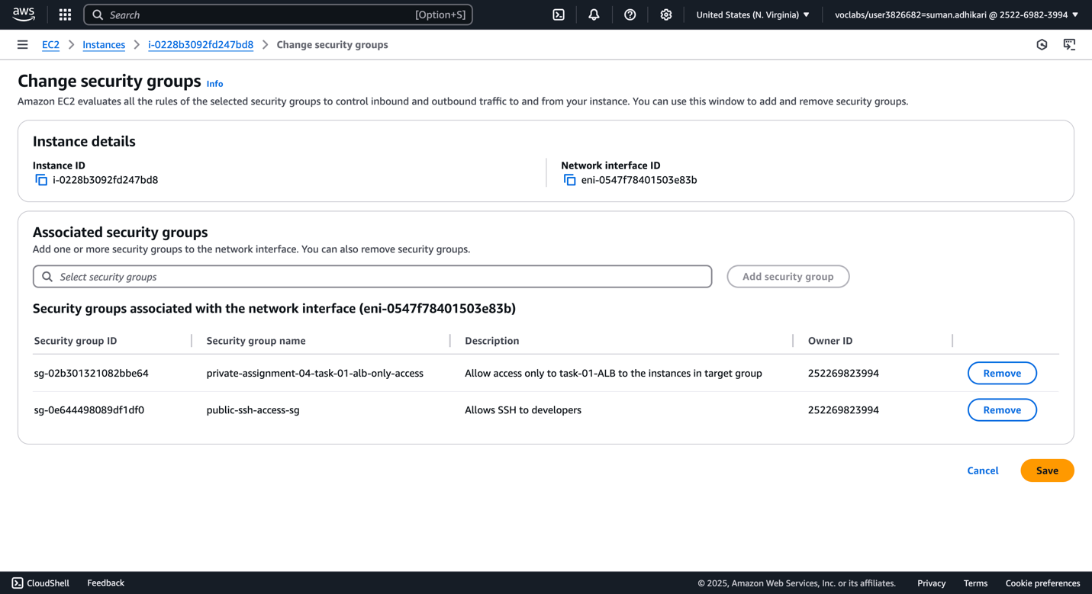

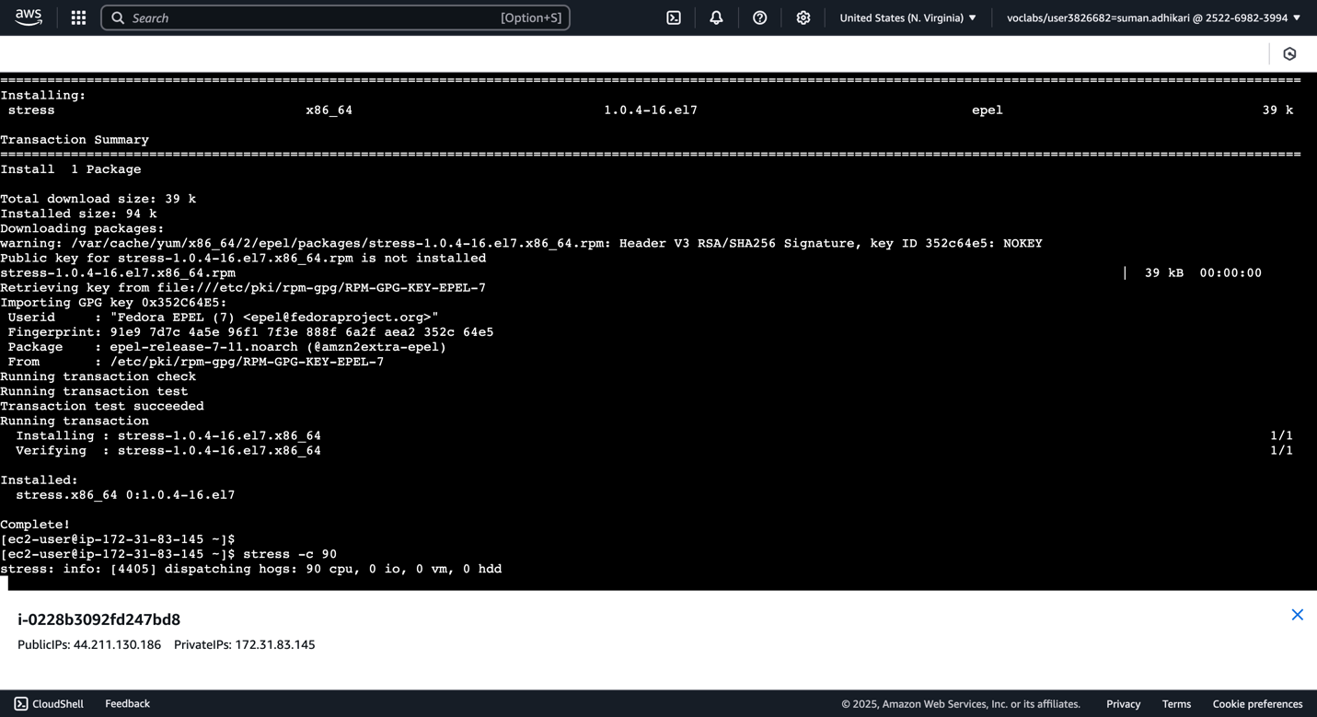

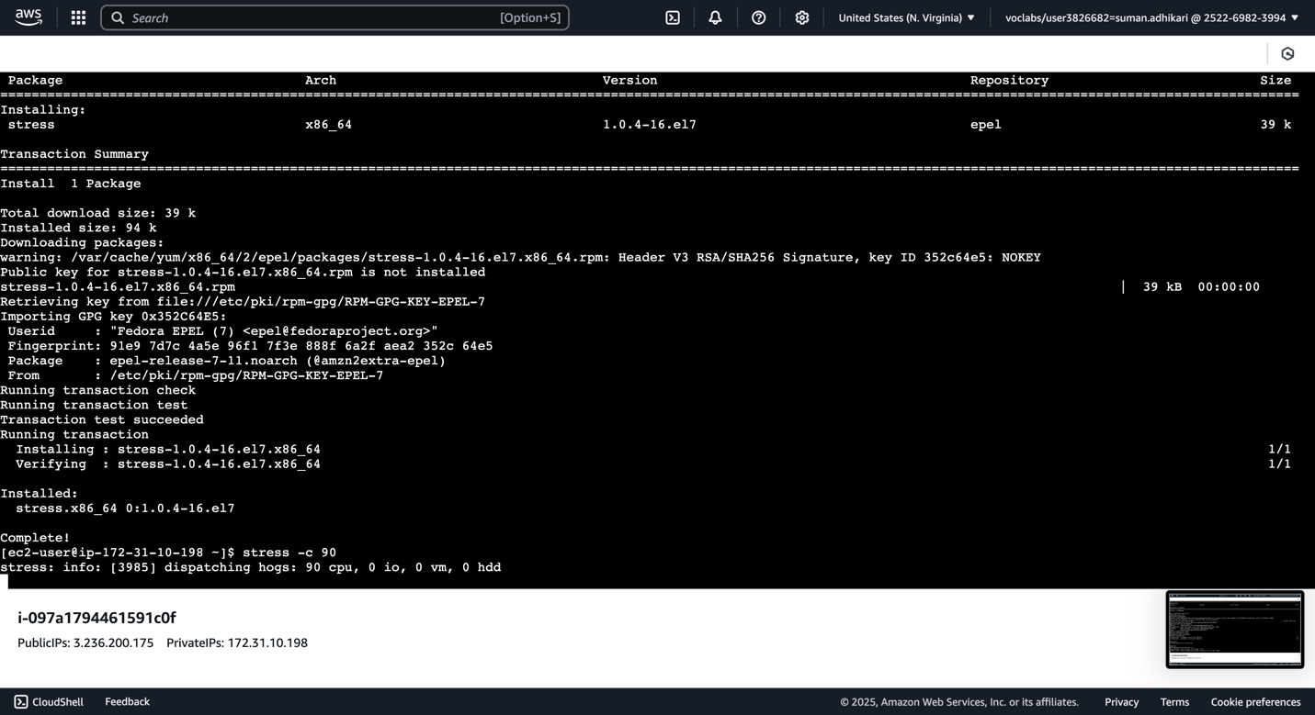

1. Check activity now for updates to ASG.

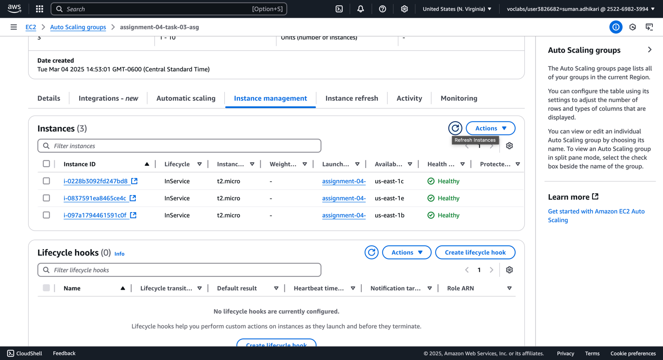

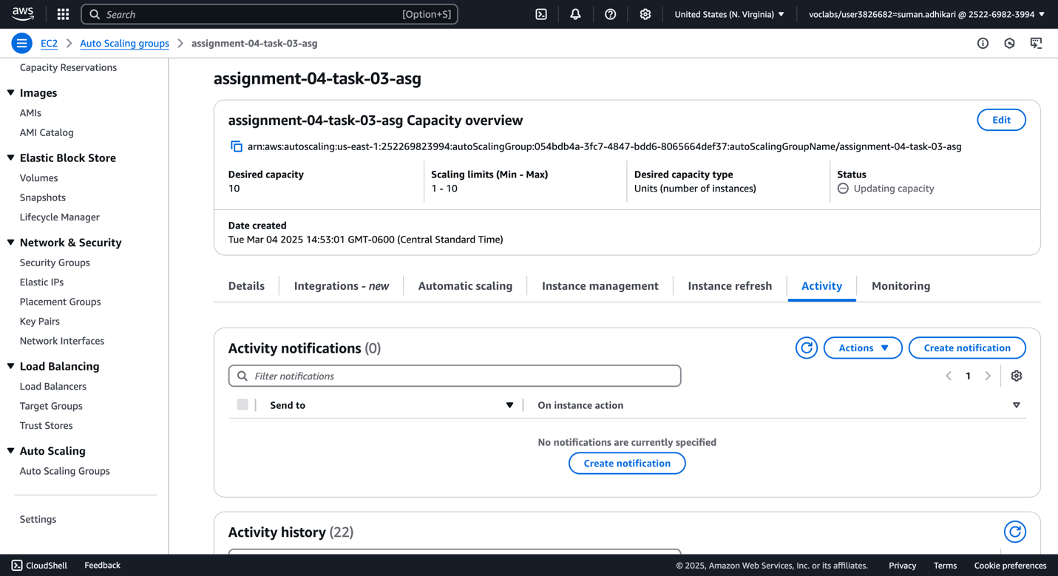

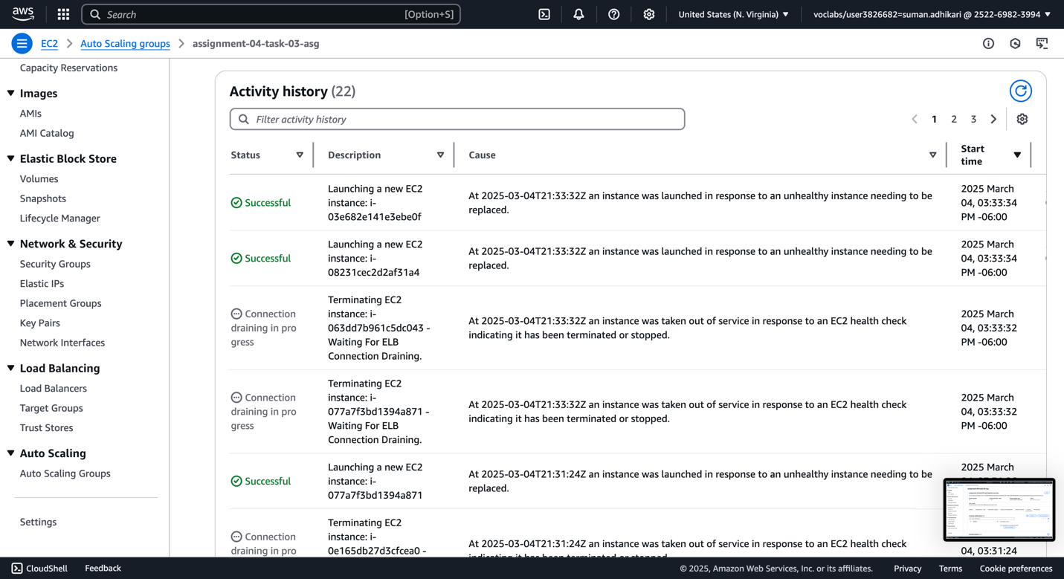

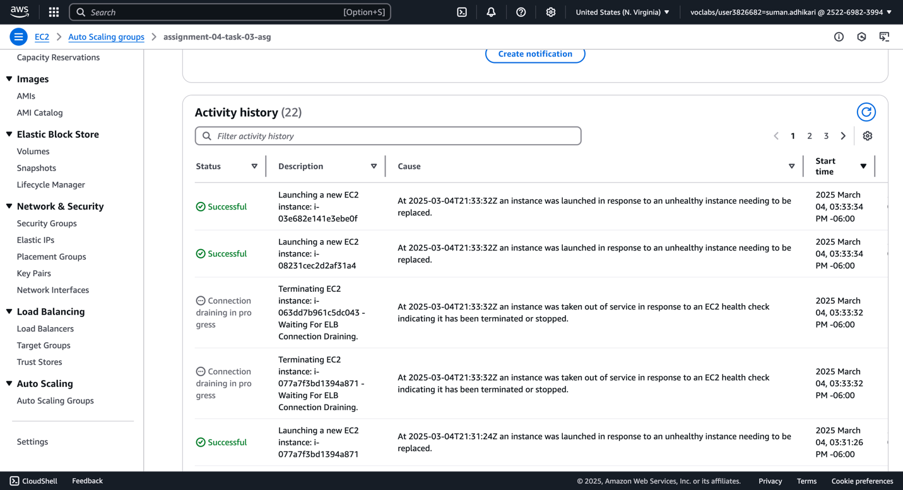

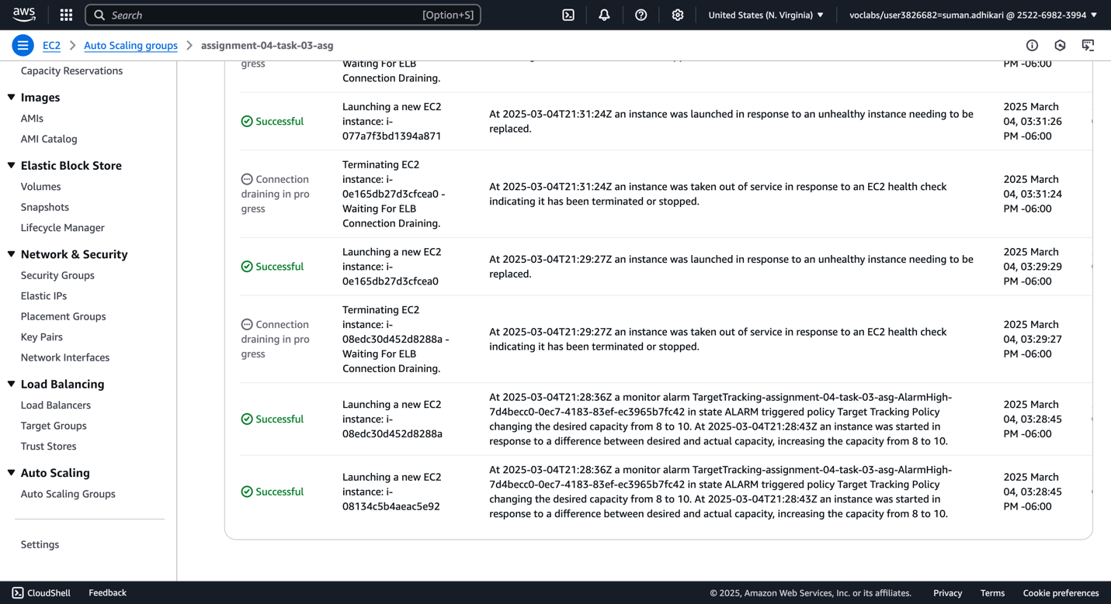

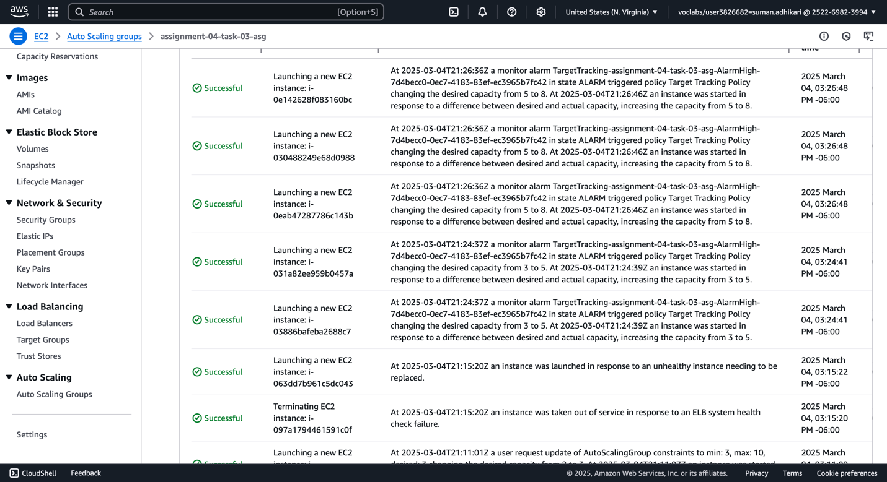

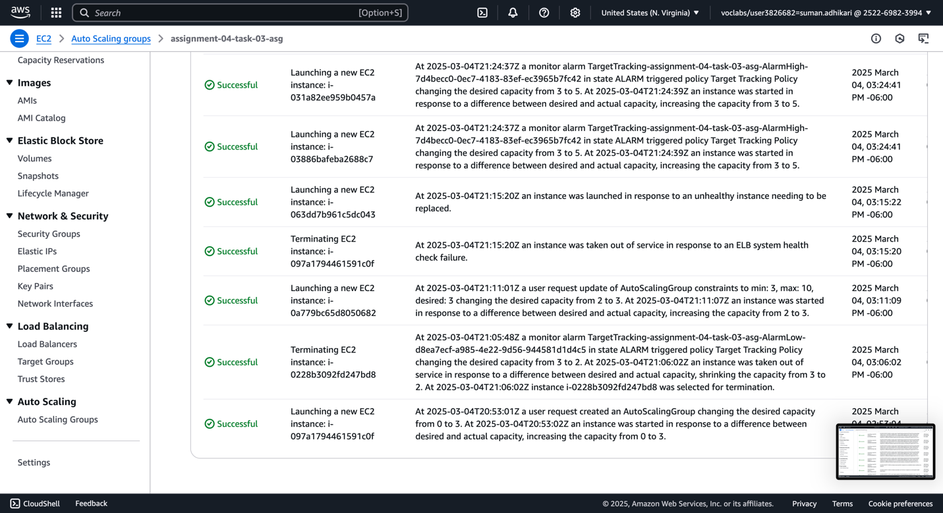

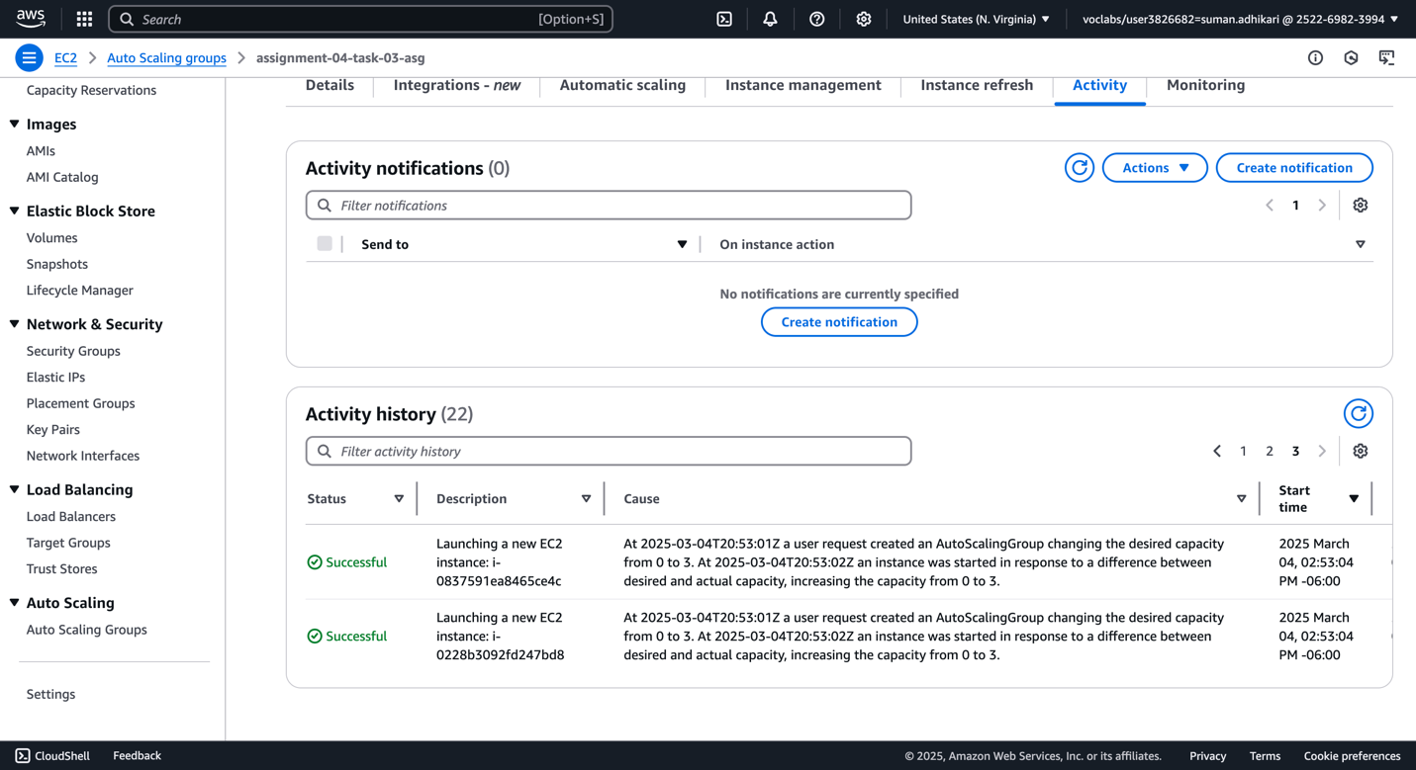

1. Check response from the ALB now.

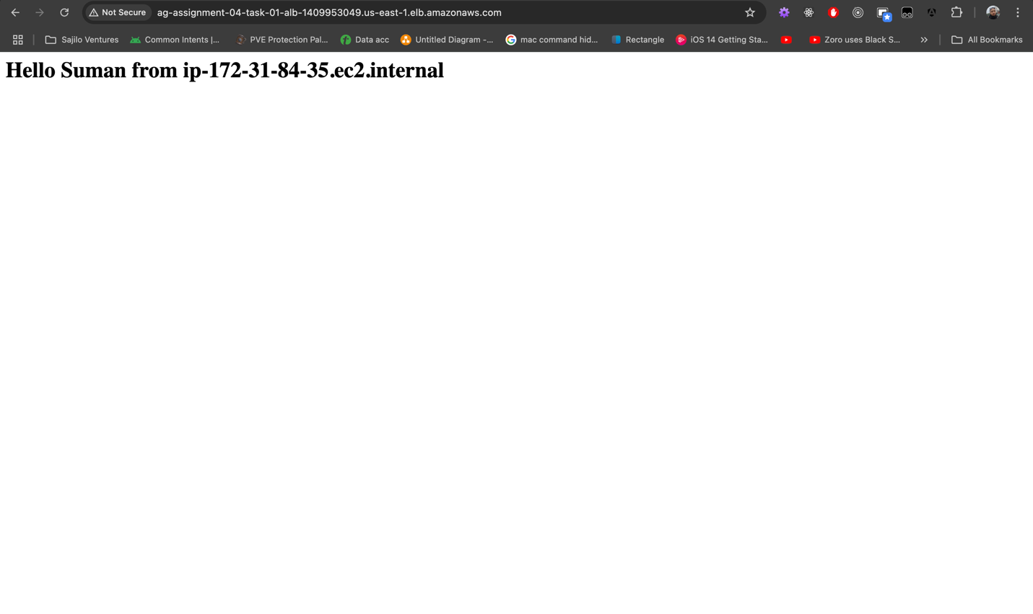

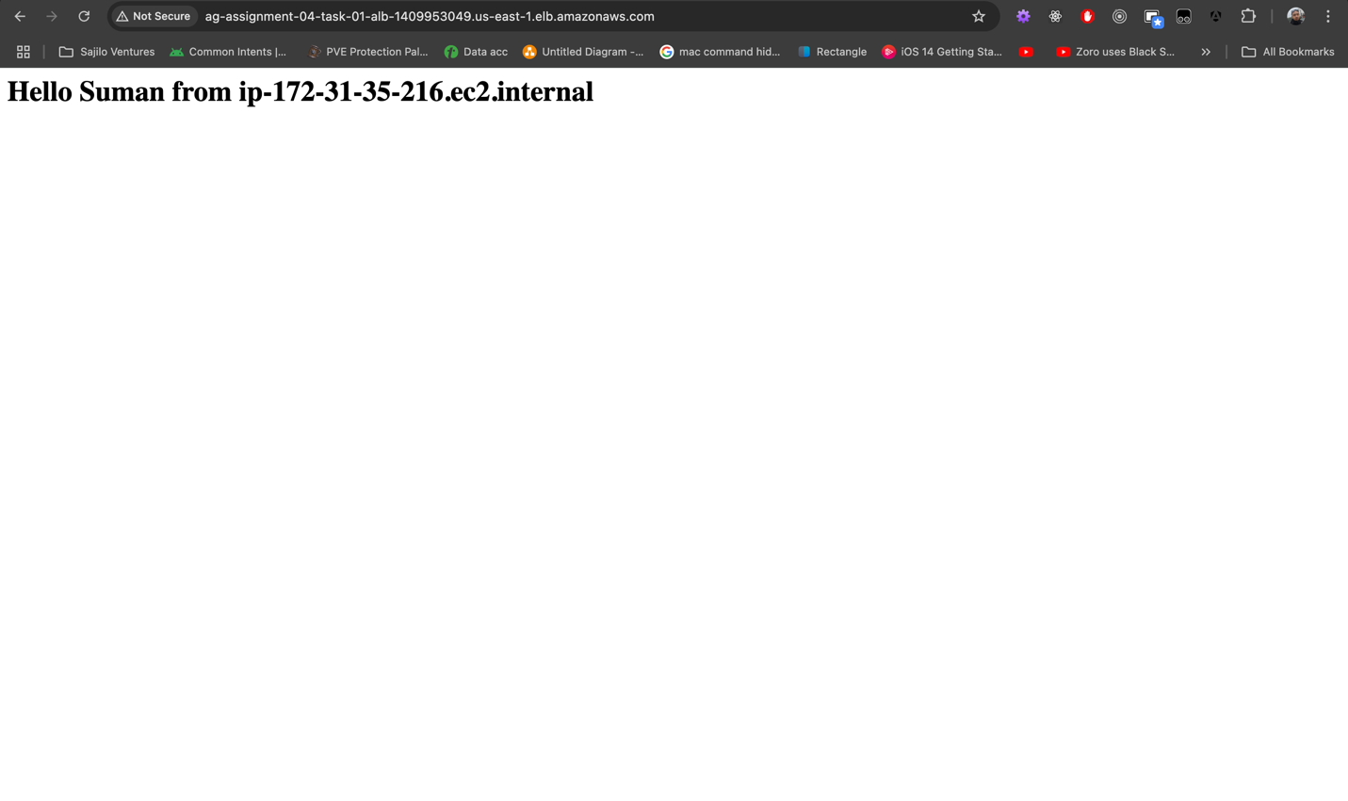

## Task #4 – Cleaning up all services

Nothing much to see here. First, we set the maximum, minimum and desired capacity to 0 in ASG. Then we remove the ASG. Next, the ALB and NLB are deleted. Then we remove then target groups. Afterwards, we terminate any EC2 instances still running on the server. Optionally, remove unused security groups as well.

1. Set capacity to 0 (min, max, desired) in ASG and delete ASG.

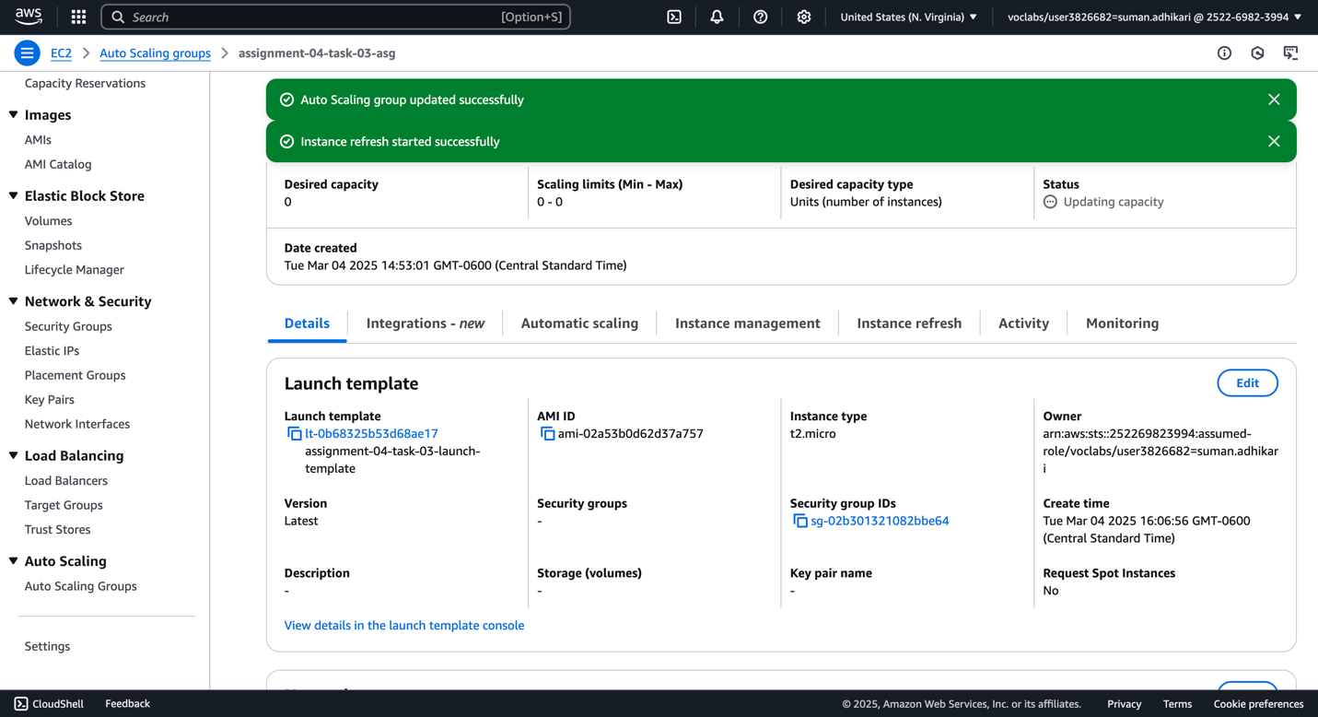

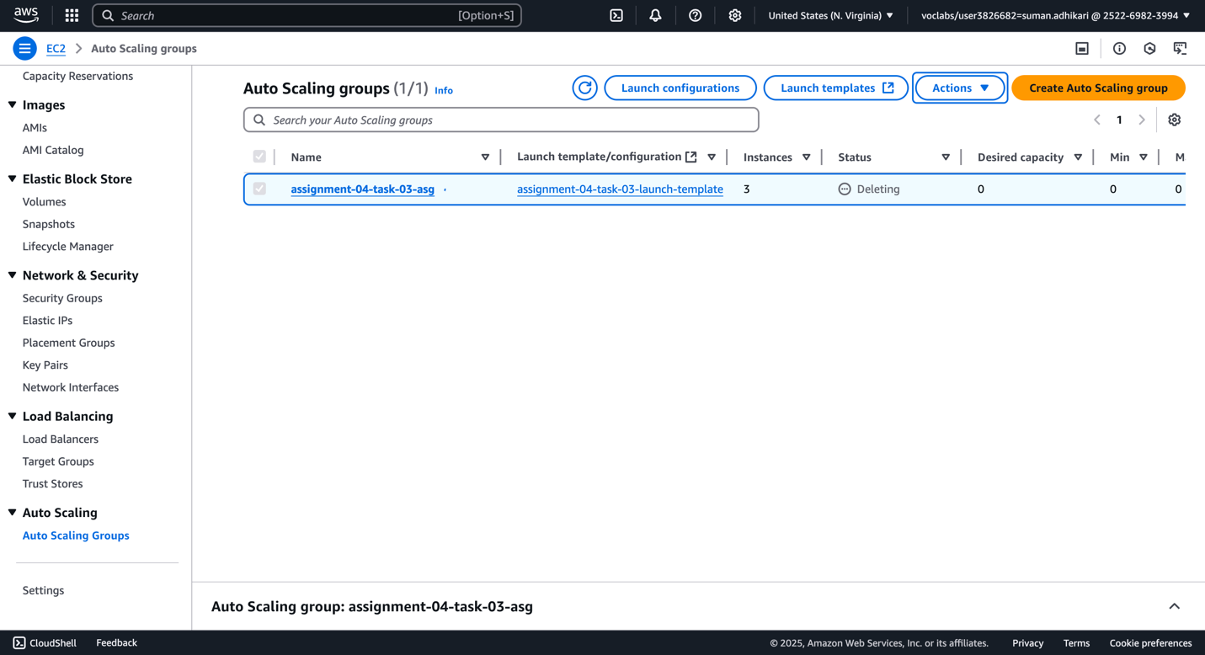

1. Delete ALB and NLB load balancers.

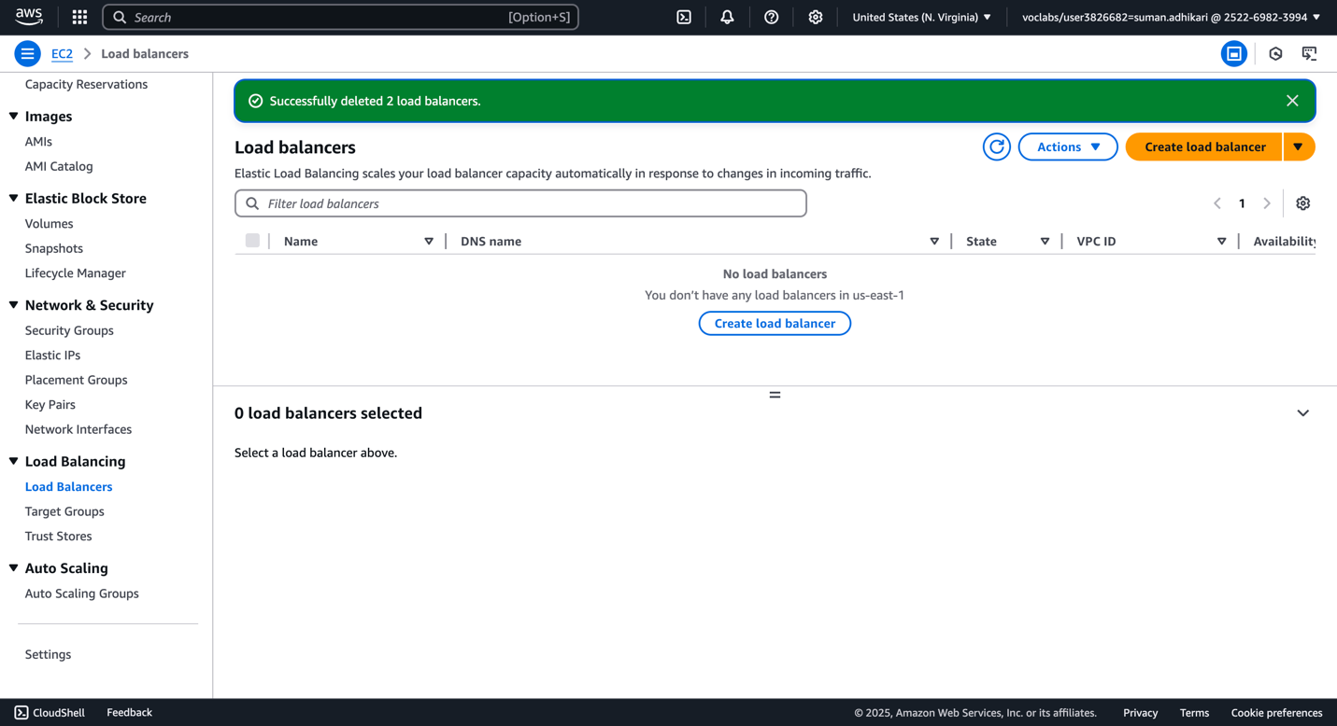

1. Delete target groups.

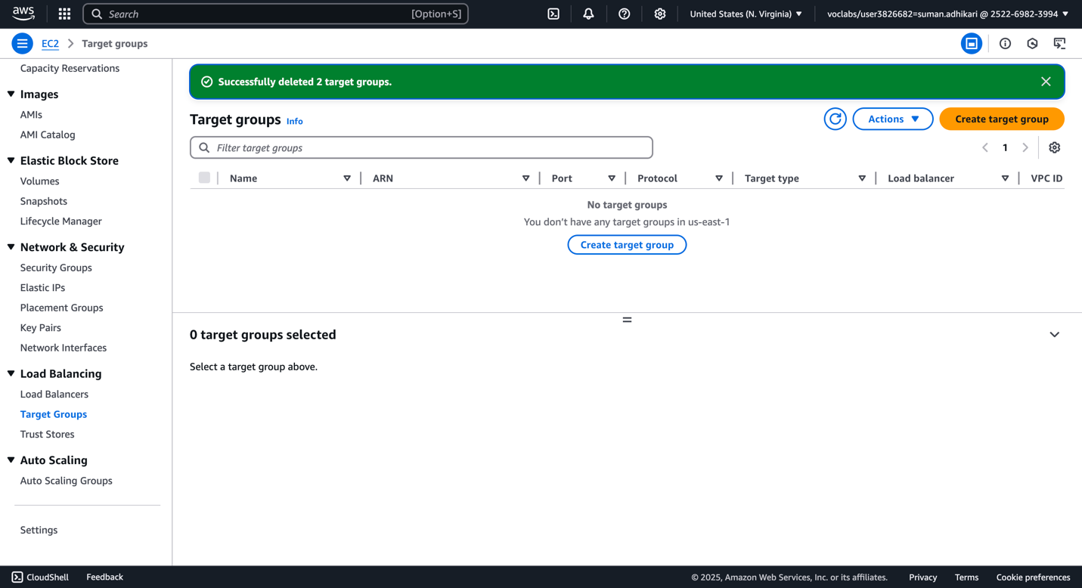

1. Delete Launch Template.

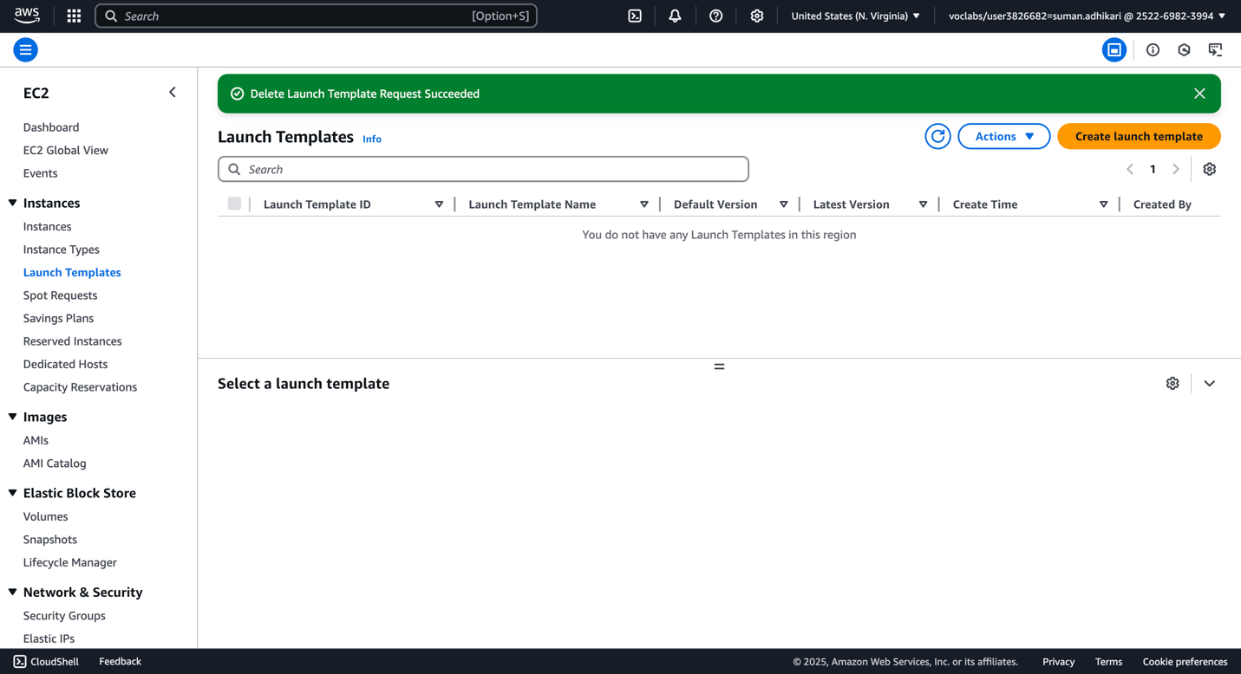

1. Delete any pending instances.

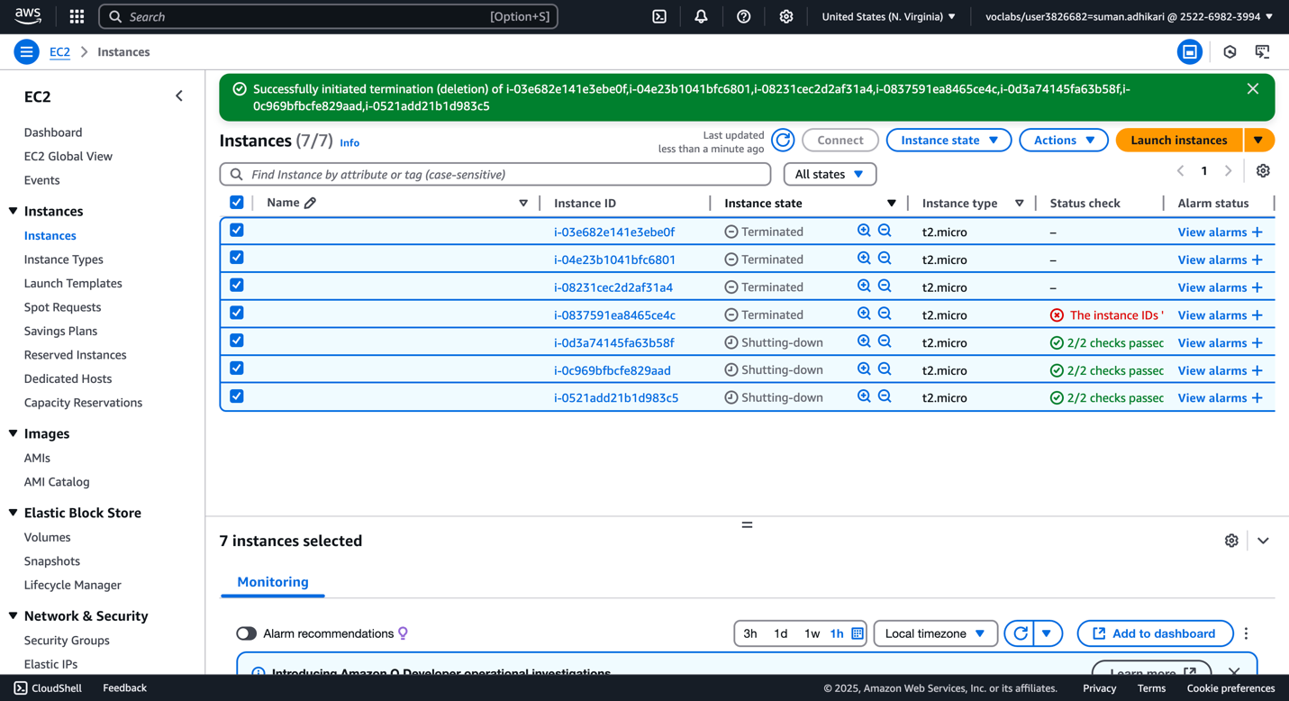

-- insert into `orders` from writer instance

INSERT INTO `orders` (`product_id`, `qty`) VALUES

(1, 2), -- 2 Laptops

(2, 1), -- 1 Smartphone

(3, 3), -- 3 Wireless Headphones

(4, 5), -- 5 Gaming Mice

(5, 2), -- 2 Mechanical Keyboards

(1, 1), -- 1 Laptop

(3, 2), -- 2 Wireless Headphones

(2, 4), -- 4 Smartphones

(4, 1), -- 1 Gaming Mouse

(5, 3); -- 3 Mechanical Keyboards